Running drop-in advice services in a university setting
Dr John Russell*

Running drop-in advice services in a university setting
In October 2011, London South Bank University (‘LSBU’) opened a new Drop-In Legal Advice Clinic where law student volunteers – working under the supervision of practising solicitors – provide free, on-the-spot, face-to-face legal advice to the general public. Our aim was to establish a drop-in advice service which would deliver a tangible benefit to the local community, develop students’ practical knowledge of the law in context, and provide a basis for developing a teaching and learning resource for other higher education institutions. In February 2012, we were highlighted in the Million+ think tank’s report on innovative teaching in modern universities, ‘Teaching that Matters’, as involving students in a valuable community service while gaining real-world legal experience, developing transferable skills and enhancing their employability prospects. In April 2012, we won a £5,000 LSBU Vice-Chancellor’s Enterprising Staff Award for our demonstration of enterprise in enhancing the student experience and employability, providing a significant benefit for the local community, and demonstrating a wider significance to other higher education institutions nationwide. The Legal Advice Clinic is now key to the marketing strategy for the Law Department. This paper describes our new service in its first year of operation.

Why run a drop-in advice clinic
Different institutions across the country are running a whole variety of interesting clinical legal education projects that are unique to them. However, the underlying basis of most university law clinics is the ‘letters of advice’ model as described by LawWorks in its “Sample Law School Clinic Handbook”. In this model, there is no public drop-in service. Potential clients telephone the clinic and speak initially to the Centre Administrator. The administrator passes brief details onto the Supervising Solicitor who takes a view as to whether the inquiry is appropriate to be handled by the clinic: “Factors taken into account include urgency, complexity and available expertise and whether or not the case is likely to be of educational benefit to the students.” If an inquiry passes this assessment, then an initial appointment will be for the client in at least one week’s time. A team of students will be assigned to the matter and begin preliminary legal research based on the information provided by the client in the initial telephone-call. After a week of research, the students meet the client for the first time and conduct a “fact-finding” interview where the giving of advice is strictly prohibited. The client leaves. The students have a post-interview review with the supervisor. There is a further reassessment as to whether the inquiry is suitable to be handled by the clinic. If the inquiry is deemed suitable, the students conduct further legal research and then over at least the next two weeks draft successive versions of a letter of advice for the supervisor to check. When the letter of advice is finally approved, it is sent to the client. Advice is only given by writing.
The drop-in clinic model works much more like a Citizens Advice Bureau or Law Centre. The core service is delivered at open-door drop-in sessions where members of public simply turn up, and are given on-the-spot face-to-face legal advice. Working under supervision, student volunteers interview and assess clients, research the enquiry while the client waits, and then give information and generalist advice, and/or signpost and refer to other local advice agencies and solicitors. There is also the option to refer clients to the Clinic’s own appointment-based evening sessions, where volunteer solicitors give face-to-face specialist advice in a number of practice areas. At these evening sessions, students shadow the volunteer solicitor, and assist by writing up the attendance note.
The main benefits of the drop-in model include that with suitable premises on the public highway and some local publicity, clinics are likely to find themselves inundated with clients. They will develop close working links with their local network of legal advice providers. According to Schön’s terminology of ‘high ground’ and ‘swamp’ that describes the distinction between the rarefied artificiality of law exam problem questions and the messy reality of the undigested world, students are dropped in the deep end by making them the first point of client contact without any prior filtering. They will be presented with people who do not necessarily have a readily identifiable legal problem and learn to assist clients in translating their concerns into legally recognisable categories and provide concise explanations of legal concepts and processes which will be entirely new to people. This intensively develops their interview skills, practical legal knowledge and understanding of client care - in particular, learning to be non-judgmental and non-discriminatory towards clients and their problems, and providing the best possible service within the time-constraints of a busy drop-in service.
The table below compares the two models. Although it is convenient to describe them in opposition, there is clearly a lot of scope for picking and mixing elements of both models - for example, it would be easy to design a clinic that used the drop-in core service as filter through which it referred on to any number of satellite clinical projects (which could include ‘letters of advice’ in particular practice areas where appropriate expertise existed).
Letters of advice model | Drop-in model
Enquiries are filtered for suitability and educational benefit | No filtering whatsoever
Clinics can struggle to find suitable clients | There is generally no shortage of clients
Advice in writing only | Face-to-face advice
At least 3 weeks from client’s first contact until the letter of advice | Legal advice is instantaneous
Tends to function separately from the local legal advice network | Deeply embedded in the local legal advice network
Students are forewarned about the nature of the enquiry and research it in advance | No forewarning or research prior to meeting the client – students are plunged into Schön’s ‘swamp’
No requirement for premises on the public highway | Requires premises suitable for public drop-in
Easy to restrict enquiries based on available staff expertise | Difficult to restrict enquiries because of  the open door policy – supervisors need to have a good basic working knowledge of social welfare law at generalist advice level or above
Can proceed to casework and representation | Can proceed to casework and representation

Levels of advice
In order to describe the drop-in model, it will help to explain the generally accepted hierarchy of legal advice provision for social welfare matters.
The lowest level of advice is basic information. Typically, this will involve giving a client a leaflet or a factsheet, or in some other way taking them through standardised information which is not tailored to them as an individual. Anyone living in the UK can access that advice by going to the Citizens Advice Bureaux website, where they maintain a publicly available online resource called adviceguide. If a client visits a CAB in the UK, they will typically get a 10 minute triage appointment with a “gateway assessor” who will see if they can resolve the enquiry at the level of basic information.
The next level of advice is generalist advice. This is much more sophisticated than basic information. The adviser is now dealing with the client as an individual, tailoring advice to their particular circumstances. It will be based on advice resources that the general public does not have direct access to - principally, Advisernet which is a vast subscription-only resource maintained by CAB, and supplemented by various weighty practitioners handbooks on welfare benefits and other matters. This is the second-tier of service at CABx in the UK. If the 10 minute “gateway assessor” appointment cannot resolve the enquiry, then the client will go through to a full generalist advice appointment, typically one hour long. This could be a one-off appointment, or there could also be casework at that level - for example, complex debt management where a client needs ongoing help (depending on what funding the particular bureau has).
Generalist advice is a massively complex area, which will cover all social welfare matters prior to legal proceedings. The CAB traditionally divides generalist advice into seven areas: benefits and tax credits, consumer goods and services, debt, employment, family, housing, and immigration. Generally it takes about 8-12 months to train as a CAB Generalist Adviser - i.e. before an adviser would interview and advise clients on their own, under the supervision of an advice session supervisor. In the drop-in clinic model we employ much more intensive supervision than the CABx in order that student volunteers give generalist advice to clients from day one.
The next level up in the hierarchy is specialist legal advice for people involved in (or in contemplation of) legal proceedings, provided by solicitors or some other substitute services – for example, a client might obtain advocacy services at tribunal level from the Free Representation Unit for employment or social security tribunals. In the drop-in clinic model, specialist legal advice is provided at the appointment-based evening sessions where students shadow volunteer solicitors and assist them by drafting the attendance note.
The drop-in clinic is a face-to-face generalist advice service, onto which can be added practice areas of appointment-based specialist advice depending on what links develop with local law firms.

The drop-in service
In our first year of operation, we ran two 3-hour daytime drop-in sessions each week (in the academic year 2012-13, we added a third drop-in session). Our publicity material said that we would:
- Provide basic information on any topic;
- Give generalist advice on any area of social welfare law in one-off one-hour appointments (except immigration, because we are not a registered immigration provider);
- Signpost and refer to appropriate local advice agencies and legal services; and
- Refer to the Clinic’s own evening appointment-based specialist advice sessions.
The daytime drop-in sessions worked as follows:
- One student acted as receptionist, taking initial details on a pro forma (the students rotated reception duties each week).
- Four other students worked in two teams of two. Each team had a dedicated supervisor.
- The supervisor and students collected a client from reception and took them to an interview room.
- We took initial instructions - that is, we got the client talking and found out what the problem was, gathered all the relevant information (using our standard questions booklet as a guide) and identified what the client wanted to achieve.
- Next the interview was paused briefly and the client waited while we returned to the base-room, researched the enquiry and formulated the advice.
- Then we returned to the interview room and gave the client the appropriate information and advice.
- Finally, we wrote up a succinct advice note once the client had left.
We had a maximum one-hour time-limit to complete that whole process, so in practice we advised approximately six clients in each 3-hour drop-in session.
We opened with two weekly daytime drop-in sessions providing generalist legal advice, and one weekly evening 3-hour appointment-based session for specialist legal advice in family and housing law provided by volunteer solicitors from local law firms Philcox Gray and Wainwright Cummins. Subsequently, we added evening appointments in employment law, long leaseholder matters and personal injury, with volunteer solicitors from Anthony Gold and Russell-Cooke. By the end of the year, we generally had two volunteer solicitors working each evening session, with one student shadowing each of them. The students would arrive 15 minutes before the appointment time and familiarise themselves with the drop-in case records. They shadowed the volunteer solicitor as they gave specialist advice. They took a careful note and wrote up an attendance note, which the volunteer solicitor checked and signed off.
We told clients that the evening appointments were one-off advice sessions, and that we did not offer casework or representation ourselves (however there is no reason at all why a clinic could not do this if it has the expertise and capacity). In most cases, this one-off session was sufficient to resolve the enquiry (in the sense that the client had no immediate need of further legal advice). In other cases:
- We invited clients to return to the Clinic as the matter developed and we could offer further help - and we had a small number of clients who visited us a number of times as the same matter unfolded.
- We assisted the client with finding legal representation by signposting or referring them to local solicitors.
- The client was taken on by the volunteer solicitors as a client of their firm (so long as it was made clear to the client that they had complete freedom of choice in respect of instructing a solicitor).

Outputs in our first year
Between September 2011 and May 2012 we were open for 27 weeks and conducted 192 face-to-face client interviews. The vast majority of our Clinic enquiries fell into the standard social welfare law categories (figure 1).
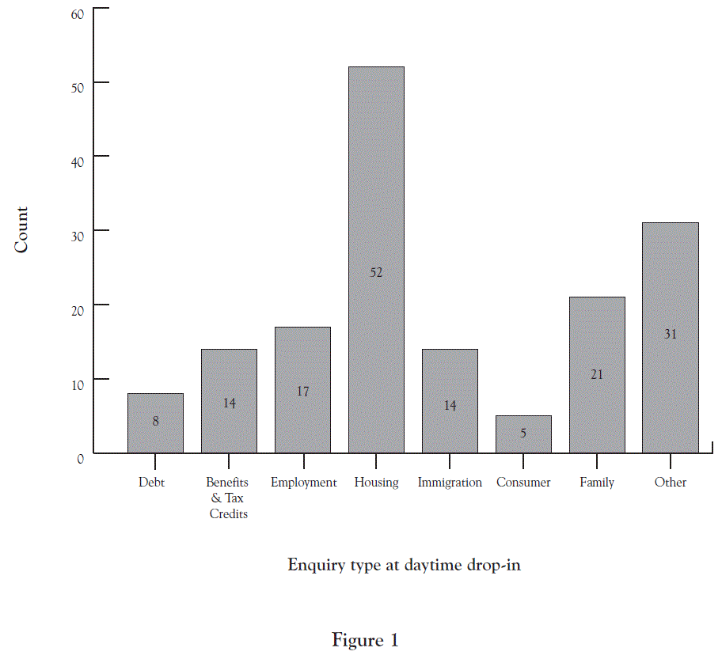
Figure 2 illustrates the outcome of enquiries at the daytime drop-in sessions. The vast majority (62%) were resolved at the level of generalist advice in the sense that the client was now able to take action and had no immediate need for further legal advice (though they might return to us or another service at a later stage, when there had been some further development). Another very substantial portion (25%) were referred to our own specialist advice evening sessions. Only a very small portion of enquiries (9%) were given basic information and signposted on; in practice, that was all immigration enquiries and a small number of commercial cases that were outside our expertise.
The overwhelming majority were handled internally in our daytime or evening sessions. These statistics show that we ran a very busy and effective Clinic, with the majority of drop-in enquiries being resolved at the level of generalist advice. The high resolution figure is important because it means that we are providing a genuinely useful service for the public, which in turn means that our students get a real sense of satisfaction and completion from the work.
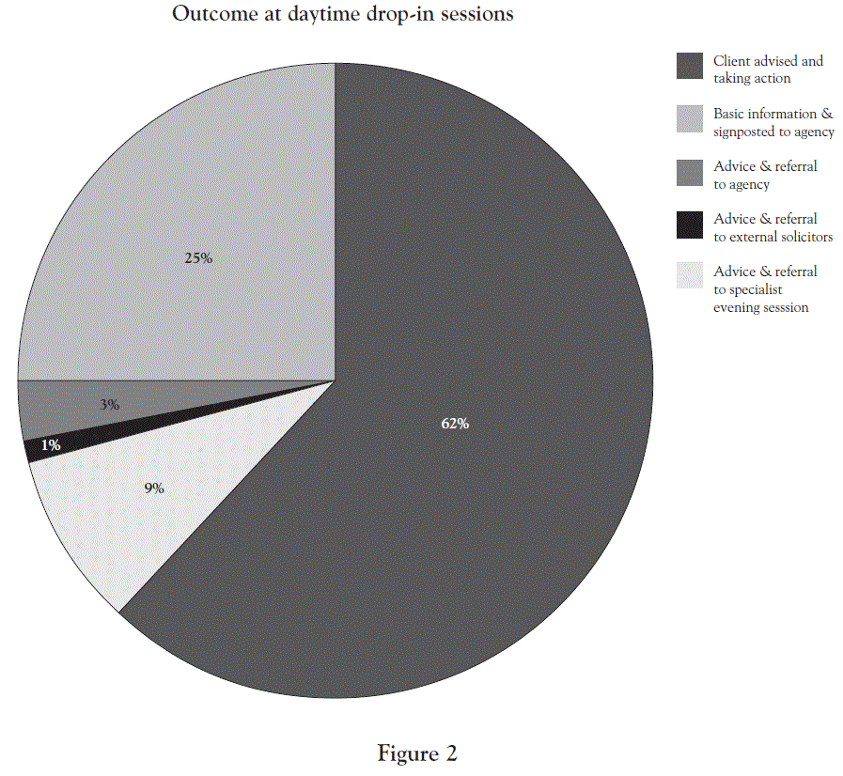

For our first 2011-12 session, we recruited 20 student volunteers. We selected applicants by way of application form and short interview. All law students were invited to apply; however we recruited towards the end of semester 2 to begin the following year, so in practice all our volunteers would be in at least their second year of study before they started their placement. We required a minimum of sixteen 3-hour sessions in order to deem a volunteer placement fulfilled. Upon completion of the placement, we provided a Certificate of Clinical Legal Education Placement and permitted the students to use the Clinic Directors as referees on any job or training applications they made. We promised them a detailed reference based on their work in the Clinic.
We gave our student volunteers two days initial training in the week prior to Week 1 of the semester. This was jointly delivered by us and local Citizens Advice Bureau staff and covered general matters such as working with clients, interview skills, using information resources, our policies and procedures, and how to refer and signpost to the local community advice network. All the rest of our training (i.e. all the substantive law) was delivered on-the-job. This is very different to how the CABx trains and works. A CAB Generalist Adviser training is much more front-loaded - there will typically be many weeks of training sessions about the substantive law before an adviser ever goes near a client, but once trained an adviser works under arms-length supervision. One CAB Advice Session Supervisor will supervise multiple Generalist Advisers working individually (figure 3).
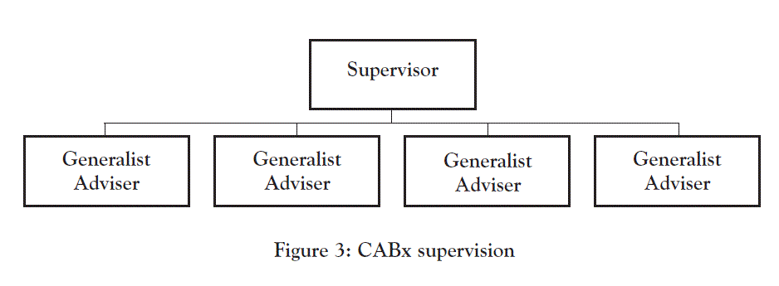
We chose to run our project on a much more modelling and experiential learning basis – partly from choice and wanting to ensure the project had educational benefit (rather than simply being pro bono work) and partly because we had no scope to timetable a longer initial training. Our students work in teams of two with a dedicated supervisor. This means we are committed to a very high staff/student ratio, and there are no economies of scale in our model - if we want to add another student team then we need to add another supervisor.
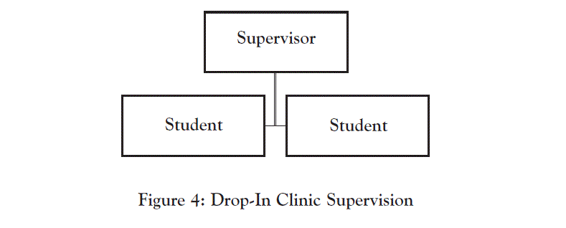
By joining the LawWorks group of clinical legal education projects, our student volunteers also had access to the comprehensive programme of LawWorks training sessions. This programme cycles through a wide range of social welfare matters and advice skills every semester. The sessions are principally intended for volunteer solicitors working in clinical projects and they are delivered at a fairly high level. We encouraged our students to attend as many sessions as possible, or listen to the accompanying podcasts available online. Generally students found that they got more out of the training sessions once they had a certain level of experience in the Clinic.

Student progression and retention
For our 2011-12 session, we recruited 20 volunteers. With hindsight, we under-recruited. Two volunteers dropped out over the summer for personal reasons and did not attend the initial training. Two volunteer placements were terminated at the start of Semester 2 - one at the student’s own request and one for persistent unreliability. Three further students reluctantly withdrew from the project for personal reasons. We still managed to run the Clinic very successfully, and never had to close the Clinic due to low student numbers. However, for the 2012-13 session we recruited substantially more students to give sufficient allowance for terminated placements and withdrawals.
At the start of a student’s placement, the supervisor modelled every stage of the 4-part process:
- Taking initial instructions;
- Researching the answer;
- Feeding the advice back to the client; and
- Writing up the case record.
But we very quickly moved on to collaborating with the students in the process. Almost immediately, we required them to do the research and write up the note (with less and less guidance as their placement progressed). Next we encouraged them to feed the advice back to the client when we went back into the room. Finally, we invited them to take initial instructions from the client.
In our 2011-12 session, all our students learnt to research real-life legal issues and write professional quality case notes. Their writing skills - their ability to identify what elements were legally relevant, and to present that information clearly, precisely and concisely - improved tremendously. 85% of students progressed to giving face-to-face advice to clients - that is, once instructions had been taken, and the legal research was done, they formulated the oral advice and delivered that in a clear, systematic manner that was appropriate for the individual client. 69% progressed to taking initial client instructions, which we consider the most challenging stage of the advice process - going into the room without any forewarning, making sense of the client’s story and asking all the relevant follow-up questions. Given that it takes about 8-12 months to train as a CAB generalist adviser, and we only have our students for 16 sessions (which equates to 48 hours) we are very pleased with that progression rate; although we are providing a very high level of on-the-job supervision - much more than a CAB is able to do.
Originally, we hoped to retain our experienced volunteers into the following year and pair them up with new recruits so that we were not beginning from square one and training up all the students from scratch every year. However, in practice this was impossible to arrange. Our university managers wanted to see as many new students benefiting from the project (rather than existing students taking up volunteer places in the following year). In any event, the student teaching timetables gave little scope to pair up students from different years in the same Clinic session. Other institutions may not be restricted in this way, and may be able to utilise experienced student volunteers to supplement direct supervision by staff.
At the end of the year, student volunteers completed a two-page feedback form. Overall, their feedback was excellent. 92% of students said their practical legal skills were very much improved from taking part in the Clinic. 92% of students rated the Clinic placement as very good or excellent overall. We were inclined to regard a successful placement as a student who progressed all the way through to taking initial instructions, but judging from the student feedback it was not necessary for a student to do that in order to rate the project highly. Two students who did not manage to progress to feeding back advice or to taking instructions, both said their practical legal skills were very much improved, and rated the placement as excellent. Even on its own the researching, writing up, and shadowing the drop-in service and the specialist evening sessions was very worthwhile for them.

Staff, premises & insurance
Our Drop-In Clinic is currently an extra-curricular clinical legal education project. Our two Clinic Directors are both lecturers in law and practising solicitors. Very significantly, both the Clinic Directors also have extensive experience of delivering generalist advice drop-in services. Approximately half their standard teaching allocation is given over to Clinic supervision - so together this is approximate to one full-time member of staff (there is no additional administrative support). In our first year, we received generous donations from Russell-Cooke and Anthony Gold solicitors. However, it is likely that we will need to embed the Clinic to some extent to ensure its long-term financial viability and we are still considering the best way of doing so.
The London South Bank University main site is located very close to Elephant & Castle, a major transport hub in the London Borough of Southwark. It is located on the south side of the Thames and bordered by Lambeth and Lewisham, with the City of London and Tower Hamlets north of the river. Tate Modern, the Royal Festival Hall, the Globe Theatre and Borough food market are nearby. However, Southwark was ranked the 17th most deprived area out of 354 local authorities and districts in the Indices of Multiple Deprivation 2004 based on an overall aggregated measure of deprivation (income, employment, health, education skills, crime etc). The Clinic premises are part of the campus but on the high street - with a large street-level disabled-access reception area, two interview rooms, a lockable back office and a base-room teaching space.
It was very evident to us that there was a huge amount of unmet local need for legal advice in social welfare matters. Early on in developing our Clinic project we made a site visit to Peckham CAB and saw 60 people queuing when the doors opened at 10 am and another 30 who arrived before the session ended. If you are considering developing a drop-in clinic and you are unsure about the needs of your local community, then start by contacting your local CAB and Law Centres. They will be able to give you a clear idea of the nature of the enquiries they deal with, and whether there is unmet need in your area. It is very likely that there will be, even if it is not on your doorstep. If you are a campus-based university, think about a town-based outreach.
Despite being located at a major South East London transport hub where the local CAB will regularly have 60 people queuing outside, we still had to do a substantial amount of local publicity in the first few weeks to get started:
- We sent out over 3,000 leaflets to every advice agency, library, GP surgery, and anywhere else that we thought might have potential clients.
- We got our service listed in every online directory that we could find.
- We networked extensively with local services.
- We put a huge banner on the front of our building.
- We drafted press stories for local free papers and websites.
After that we seemed to reach critical mass, and when we reopened after the Christmas vacation, we had clients queuing up to be seen from day one. Lydia Bleasdale-Hill’s recent excellent survey of clinical legal education projects also makes a number of suggestions about ways to publicise an advice service.
With regard to security, every CAB in the country runs an open-door public drop-in without any security whatsoever. We have a general security team on campus but none in the Clinic building itself. In 192 face-to-face interviews in the Clinic, we have only had one client whose conduct required us to call the general university security and he left once security arrived. It is certainly very challenging to have to deal with situation like that while being observed by students looking to you to model best practice, but handle it well and debrief it properly and that becomes a very powerful learning experience. We would only stress that you should have a precise understanding of exactly what powers your security staff have (i.e. can they lay on hands and physically remove someone from the premises, or do you need the police in order to do that). We recommend that, prior to opening your doors, you meet with your security team to discuss their powers and the most effective way of contacting them urgently, and whether you should call the police at the same time. However, it is important not to allow very occasional difficult clients to have a disproportionate impact - people tend to remember the extremes and recall the one client who kicked off in reception rather than the 191 that did not. The prospect of difficult clients should not put anyone off running a drop-in service. The overwhelming majority of our clients are extremely satisfied and effusive in their thanks and that gives students a powerful sense of their capabilities.
Our Clinic is covered by our general University insurance. If you are considering opening a project and your institution insists that you obtain separate professional indemnity insurance then you can do this easily and inexpensively. LawWorks particularly recommends AdviceUK who are familiar with law clinic work.

Drop-In Clinic Operational Manual
In July 2011, we obtained a Higher Education Academy Teaching Development Grant to produce teaching and learning resources for a drop-in model of clinical legal education. Our free 73-page Drop-In Clinic Operational Manual was officially launched at LSBU’s ‘Clinical Legal Education - Form and Funding’ conference on Friday 15 February 2013, at which we and other institutions running innovative clinical projects shared their work with over 100 academics, practitioners and students. The Manual can be downloaded from the LSBU website (http://www.lsbu.ac.uk/ahs/downloads/law/lsbu-drop-in-clinic-manual-v1) and links to all the conference materials are available on the HEA Social Sciences blog (http://blogs.heacademy.ac.uk/social-sciences/2013/02/22/clinical-legal-education-form-and-funding/).

* Lecturer in Law / Solicitor-Advocate (Higher Courts Civil Proceedings. London South Bank University
Million+ (2012) Teaching That Matters, http://www.millionplus.ac.uk/research/teaching-that-matters.
LawWorks Student Pro Bono Report 2011 and Lydia Bleasdale-Hill, The Experience of Establishing and Maintaining Pro bono Projects within an Educational Setting: A Narrative (Sept 2011) - both at lawworks.org.uk.
Derived from an original manual authored by the law clinic staff at Sheffield Hallam University in 1999; revised by the College of Law in 2006. LawWorks Sample Law Clinic Handbook 2006 http://www.lawworks.org.uk/index.php?cID=163&cType=document accessed 25 August 2012.
ibid p7.
Brayne, Duncan and Grimes, Clinical Legal Education: Active Learning in Your Law School (Blackstone, 1998) pp35-36.
Bleasdale-Hill (2011 – n1) confirms that written advice clinics can be “desperate for clients” and available interview slots are unfilled (p11).
www.adviceguide.org.uk
It is issued on CD-ROM in monthly updates. The annual subscription charge for voluntary organisations is currently £539 + VAT: http://www.citizensadvice.org.uk/index/adviser_resources/advisernet.htm
In relation to welfare benefits, Child Poverty Action Group provides the finest hard-copy resources and training events. Their Welfare Benefits and Tax Credits Handbook (updated annually) is essential: http://www.cpag.org.uk/welfarerights. Disability Rights UK (formerly Disability Alliance) produces superior resources on disability benefits, especially the beautifully readable Disability Rights Handbook (updated annually): http://www.disabilityrightsuk.org.
Students initially observe the supervisor taking instructions and giving advice, until they progress to doing this themselves - see ‘Student progression and retention’ below.
http://www.lawworks.org.uk/.
See n2.
http://www.adviceuk.org.uk/supporting-you.

