**Reflections on Adrian Evans’s Contributions Internationally**

**to Clinical Legal Education and Legal Ethics**

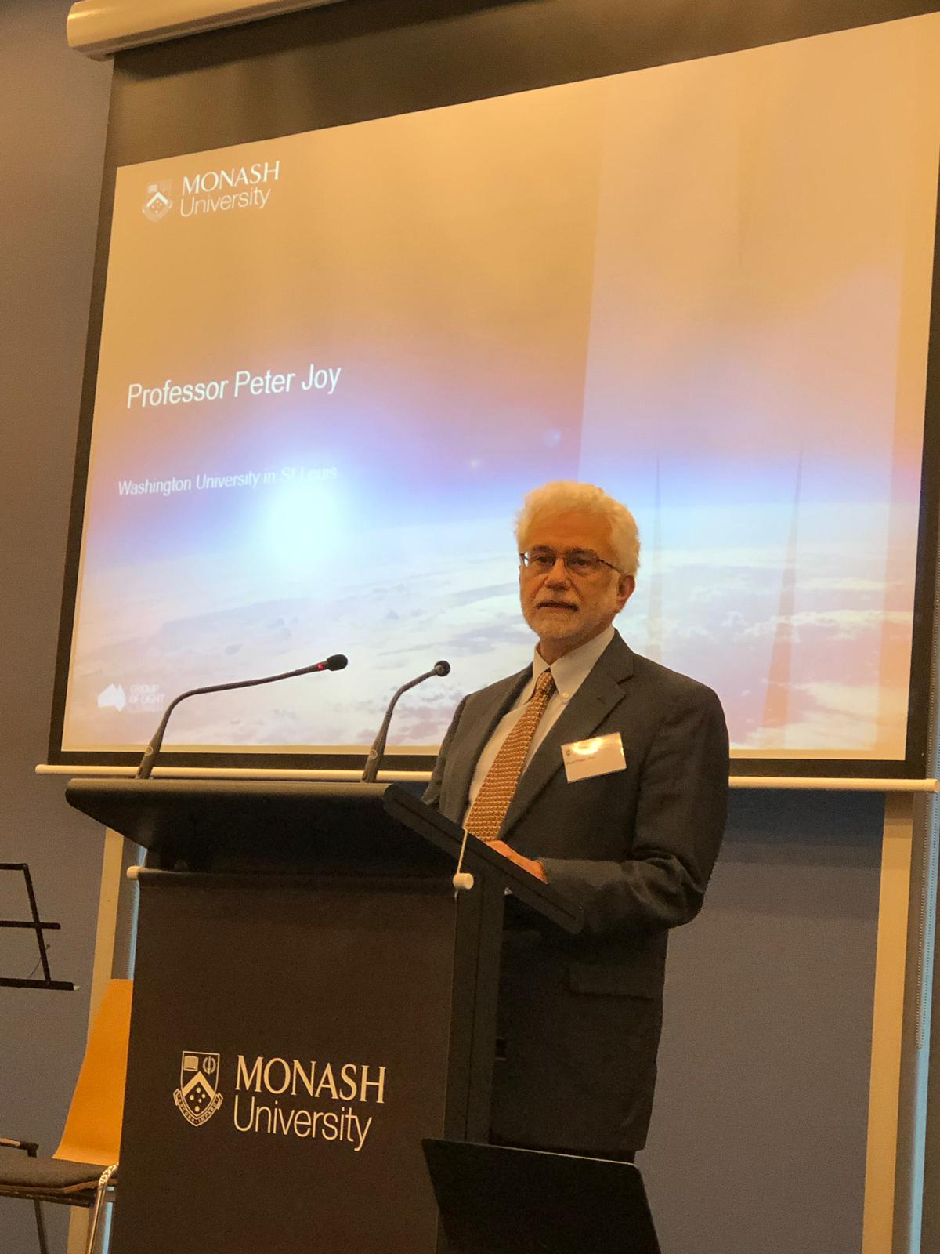Peter A. Joy[1]*

It is a privilege to join you today in honoring the work of Adrian Evans. You have already heard much about Adrian, and I will not belabor the point too much – Adrian is a wonderful person, colleague, teacher, lawyer, scholar, and friend. Nigel Duncan has already told you much about Adrian’s work internationally, so I will focus more on his contributions to and impact on clinical legal education and legal ethics internationally. My focus is on Adrian as a lawyer, teacher, and scholar.

I assume that most of us have heard of Six Degrees of Kevin Bacon. If you have not, it is based on the theory that any two people on earth are six or fewer acquaintance links apart. With Kevin Bacon, it assumes that anyone involved in the movie business can be linked through their film roles either to Kevin Bacon or someone he worked with in six steps or less. For example, the Australian film star Toni Collette was in *The Sixth Sense* with Bruce Willis, Bruce Willis was in *The Player* with Tim Robbins, and Tim Robbins was in *Mystic River* with Kevin Bacon. That puts Toni Collette within three degrees of Kevin Bacon.

When it comes to the international clinical legal education and international legal ethics communities, everyone is within three degrees of Adrian Evans. This is a testament to Adrian’s reach, but also it is fortunate for everyone at this Festschrift. Why you may ask? Well, if you have been following along you should realize that because you know Adrian you are within one degree of Adrian, and everyone you know is within two degrees of Adrian. I strongly doubt that there is anyone on this planet who does work in the clinical legal education and legal ethics fields who doesn’t know Adrian, you, or those you know.

Adrian’s interests and motivations for the work he has done as a teacher and scholar come from his personal commitment to be an effective, ethical lawyer, and he has been, and continues to be that and much more. Adrian wrote about his philosophy in one of his many publications, the book *The Good Lawyer*. Adrian’s focus is both practical, and theoretical, as this slide about the obligations of legal practitioners illustrates.[2]

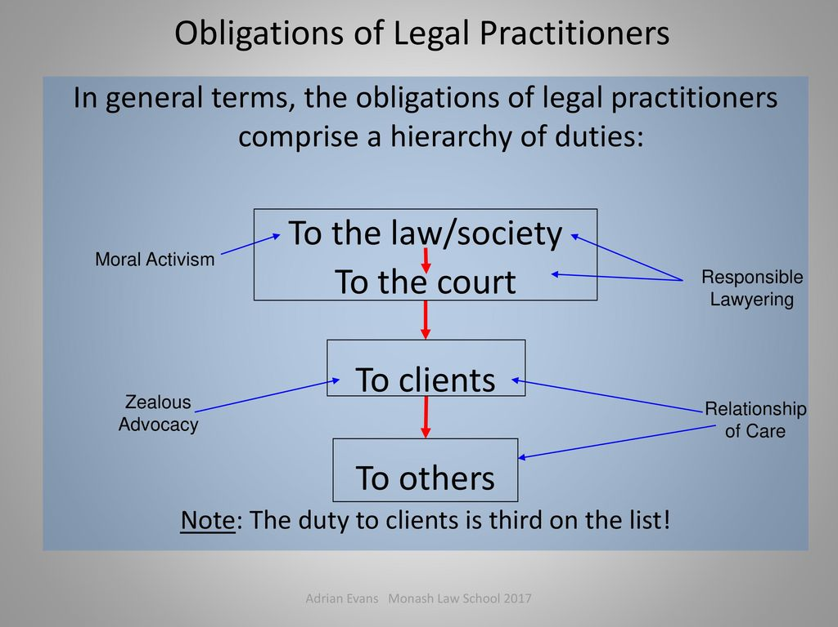

Through his work as a clinical teacher, Adrian continued to provide much-needed legal assistance to those unable to afford an attorney as he taught and mentored hundreds of students in how to be effective, ethical lawyers. By helping law students learn how to apply what they learned about the law to help individuals and families, Adrian has made a significant positive impact on society and, through the work of his former students, he continues to do so.

Adrian is also a great teacher. Adrian won various teaching awards, including the Monash Vice-Chancellor’s Award for Distinguished Teaching, and I have seen Adrian in action at conferences doing engaging, thoughtful presentations. I was also fortunate to sit in on some of Adrian’s supervision sessions with students when I was a Sue Campbell Visiting Scholar at Monash. I was impressed not only by his effectiveness as a teacher, but with his extraordinary efforts aimed at ensuring the emotional health of his students dealing with difficult issues their clients faced. I learned a lot from observing him.

Adrian’s teaching career started in the 1970s with his work on developing the Clinical Interviewing Program for Legal Studies’ students, and Professor Mary Anne Noone has discussed in depth, and much better than I, Adrian’s teaching career. But, to put Adrian’s teaching career in perspective, here is a short recap. From 1988 to 2000, Adrian was the Coordinator of Springvale Monash Legal Services, the first clinical program in Australia. During this same time, Adrian’s career blossomed as he progressed from 1988 to 1995 as Lecturer in Law, to Senior Lecturer in Law from 1995 to 2000, and he has been a Professor of Law since then. The next phase, which Dean Bryan Horrigan has recently announced is Adrian’s new status as Emeritus Professor of Law.

As a teacher, Adrian also focused on understanding, and helping all of us in the international clinical legal education community to understand, the pedagogy associated with effective clinical teaching. Here is one of his slides illustrating effective and engaging teaching.[3]

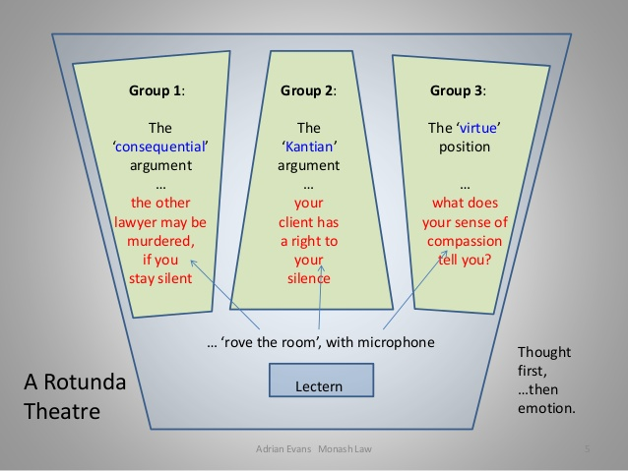

Lastly, Adrian is a prolific scholar with a global reach. From 1998 to 2017, Adrian authored or co-authored nine books, thirty-nine articles, five book chapters, five additional papers or reports, and edited or co-edited six books.[4] Adrian’s research interests in clinical legal education run the gamut of every important area of the field. Among his many works are books and articles on establishing best practices for clinical legal education,[5] student moral development in clinical legal education,[6] the pedagogy of specialist clinics,[7] practical skills development and effective skills teaching,[8] and assessment of and evaluating clinical legal education.[9] Adrian’s work has not only influenced the current generations of clinical legal educators, but Adrian’s labors promise to influence future generations as well through his publications.

Similarly, Adrian’s legal ethics scholarship is far reaching, though laser sharp on developing and inculcating ethical behavior.His most frequent areas of interest include delving inside lawyers’ ethics,[10] assessing lawyers’ ethics,[11] reinforcing the ethics of lawyering,[12] what makes the good lawyer,[13] the ethical infrastructure of legal practice in large law firms,[14] the connection between the ethics of combating money laundering and reducing global poverty,[15] and the relationship of virtue ethics to therapeutic jurisprudence.[16]

Adrian’s work and career demonstrates that it is possible to be an excellent lawyer, gifted teacher in both clinical courses and the classroom, and a highly regarded scholar. On top of all of these accomplishments, Adrian served for several years as the Associate Dean (Staff) at Monash Law School. For most of us, being proficient in any one of those four areas would be a life’s achievement.

So, it is fitting that this Festschrift recognizing the work of Adrian Evans takes place as a prelude to the *International Journal of Clinical Legal Education* Conference hosted by Adrian Evans’ home institution, Monash Law School.Everyone who knows Adrian is better for having encountered Adrian, and I am privileged to be one of his many friends. On behalf of all of us, Adrian’s students, and the clients that Adrian and his students have assisted for many years, thank you Adrian!

1. * Henry Hitchcock Professor of Law, Vice Dean for Academic Affairs, and Director of the Criminal Justice Clinic at Washington University in St. Louis School of Law. I am grateful to the *International Journal of Clinical Legal Education* and especially Professor Elaine Hall for publishing the Festschrift proceedings and Professor Kate Seear for editing this special issue.
2. This slide is from Adrian Evans, “Inside Ethical Practice,” available at <https://slideplayer.com/slide/13596714/>.
3. This slide is from Adrian Evans, “Learning Lunchbox: Thinking Through Your Ethical Response,” available at <https://www.slideshare.net/rachelsaffer/evans-learning-lunchbox-presentation-on-stimulating-ethical-thought-24-nov-2014>.
4. Adrian Evans Research Output, Monash University, <https://research.monash.edu/en/persons/adrian-evans/publications/?type=%2Fdk%2Fatira%2Fpure%2Fresearchoutput%2Fresearchoutputtypes%2Fcontributiontobookanthology%2Fchapter>.
5. Adrian Evans, Anna Cody, Anna Copeland, Jeff Giddings, Peter Joy, Mary Anne Noone & Simon Rice, *Australian Clinical Legal Education: Designing and Operating a Best Practice Clinical Program in Australian Law School*, 2017, Australian National University Press; Adrian Evans, “Best Practices: Australian Legal Education” *The Law Teacher,* 47 (3), 2013, 421-423.
6. Adrian Evans, “Client Group Activism and Student Moral Development in Clinical Legal Education*” Legal Education Review*, 2000, 179-190.
7. Adrian Evans & Ross Hyams, “Specialist Legal Clinics: Their Pedagogy, Risks and Payoffs as Externships” *International Journal of Clinical Legal Education*, 22 (2), 2015, 147-180.
8. Ross Hyams, Sue Campbell & Adrian Evans, *Practical Legal Skills: Developing Your Clinical Technique*, 4th edition, 2014, Oxford University Press.
9. Adrian Evans, “Global Agendas, Cultural Capital and Self-assessment of Clinical Legal Education Programs” *Monash Law Review*, 38 (2), 2012, 55-81; Adrian Evans & Ross Hyams, Independent Evaluations of Clinical Legal Education Programs: Appropriate Objectives and Processes in an Australian Setting” *Griffith Law Review*, 17 (1), 2008, 52-86.
10. Christine Parker & Adrian Evans, *Inside Lawyers’ Ethics*, 3rd edition, 2018, Cambridge University Press.
11. Adrian Evans, *Assessing Lawyers’ Ethics: A Practitioner’s Guide*, 2011, Cambridge University Press.
12. Adrian Evans, “(Self) Knowledge Is Power: Reinforcing the Ethics of Lawyering” *Law Institute Journal*, 86 (6), 2012, 29-35.
13. Adrian Evans, *The Good Lawyer*, 2014, Cambridge University Press.
14. Christine Parker, Adrian Evans, Linda Haller, Suzanne Le Mire & Reid Mortensen, “The Ethical Infrastructure of Legal Practice in Larger Law Firms: Values, Policy and Behaviour” *University of New South Wales Law Journal*, 31 (1), 2008, 158-188.
15. Adrian Evans, “Connections between the Ethics of Combating Money Laundering and Reduction in Global Poverty” in Maynard, P.D. & Gold, N. (eds), *Poverty, Justice and the Rule of Law: Report of the Second Phase of the IBA Presidential Task force on the Financial Crisis*, International Bar Association, 2013, 169-174.
16. Adrian Evans & Michael King, “Reflections on the Connection of Virtue Ethics to Therapeutic Jurisprudence,” *University of New South Wales Law Journal*, 35 (3), 2012, 717-746.