Third Sector Commentary: ‘Change in the Third Sector’, James Turner, Rocket Science

“All changed, changed utterly: A terrible beauty is born”

Of all the quotes on the subject of change, it’s arguably W.B.Yeats’ refrain that is best known. And for the Third Sector over the past five years, the line is certainly apt. For many charities and voluntary organisations, funding cut-backs, redundancies and closures have often, indeed, been terrible. But there has also been beauty in the way that these groups have adapted and shifted to the changed environment.

It was this mixture of changed circumstances and flexible responses that the NETSRG wished to discuss at its July 2014 meeting. We looked at three papers:

Pricing out third sector organizations, Hayley Bennett, University of Edinburgh covered the implementation of payment-by-results approaches in welfare to work programmes and their impact on third sector organisations (TSOs).

The third sector in unsettled times: a field guide, Macmillan, Taylor, Arvidson, Soteri-Proctor and Teasdale, Third Sector Research Centre, looked at three mechanisms for organisational change: restructuring and redundancy, mergers and acquisitions, and repositioning and branding.

Competencies for managing change, Crawford and Nahmias, Bond University, Australia looked at the differing skills sets of project managers and change managers. It also looked at which types of change were most suitable for project managers and for change managers.
The idea was to start by looking at one of the external policy factors (payment-by-results) that has driven change over recent years, and then to look in more detail at the ways in which TSOs have responded to change. So let’s begin at the beginning and consider the first paper on pricing out third sector organisations…

- Pricing out third sector organizations

Bennett helpfully takes a longer term perspective than just looking at welfare to work policy implementation since 2010. Instead, she considers the development of the welfare to work market in four phases:

“The New Deal programmes introduced in the late 1990s - involving a number of consortiums between TSOs, public sector organisations and some private sector organisations in delivering employment services.
The second phase of the development of the market involved the introduction of the Employment Zone (EZ) which used a number of competing providers to deliver employment targets in areas of high unemployment in the UK.

The third phase involved the introduction of the Flexible New Deal in 2008.

Finally the fourth stage began with the introduction of the new Coalition Government’s Work Programme in 2010.”

It’s during phases three and four that we see a policy shift towards payment-by-results, a top tier of prime contractors and larger contracts. And it’s these policy shifts that Bennett suggests impact on the involvement of TSOs. Fundamentally, the financial risks are shifted from the commissioners to the providers and it’s this shift that creates an ‘unequal playing field for TSOs who have capital raising limitations’.

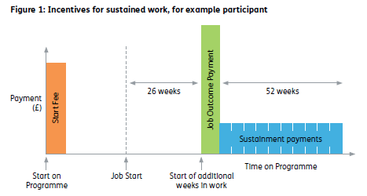
Figure 1: How contractors are paid for achieving outcomes on the Work Programme [DWP, Work Programme, 2012]

The simplest point in support of Bennett’s conclusions is the distribution of Work Programme prime contractors between TSOs and private sector organisations. As Bennett notes: “35 out of 40 (87 per cent) available prime contracts within the Work Programme were won by private sector organizations, with only three awarded to TSO organizations.”

We now have the advantage of being able to look back on several years of operation of the Work Programme. The DWP-commissioned evaluation of the Work Programme’s commissioning model suggested that the provider market is a relatively stable “unconcentrated, competitive oligopoly”. In other words, the market is competitive, but controlled by a relatively small number of providers – which is much as Bennett argues.

Secondly, it’s clear that the Work Programme is working better for Job Seekers’ Allowance (JSA) claimants than it is for Employment and Support Allowance (ESA) claimants. Inclusion in its 2014 report Making the Work Programme work for ESA claimants states: “Both the numbers of ESA participants on the Work Programme, and performance in finding them jobs, have been below the levels expected by the Department [of Work and Pensions]”. Of course, it’s impossible to say if greater TSO involvement would have changed this. But ESA claimants are, by definition, ill or disabled and have greater needs than a typical Work Programme participant. It’s arguable that TSOs could play a greater role in providing more individualised support to these Work Programme participants.

And the question, “How can TSOs play more of a role in difficult times?” brings us on to the second paper that the group looked at…

- The third sector in unsettled times: a field guide

The overall approach of Macmillan et al was to look at a range of longitudinal case studies over a three year period from 2010-2013. Waves of fieldwork over this period would help understand “how and why TSOs change, how they respond to the challenges they face, and whether and how they might flourish over time.”

The researchers adopted a field-based perspective. They explain that TSOs are actors in a number of different fields: the field of the third sector itself but also other fields including “’vertical’ fields in policy domains, such as health, family support and housing.”

The paper focused on three broad categories of strategies and tactics: restructuring and redundancy, mergers and acquisitions, and repositioning and branding.

Some of the striking findings from the report included the wide range of organisational strategies used by case study groups to restructuring and redundancy – including more positive strategies, such as using restructuring to reshape and strengthen the organisation. On mergers and acquisitions, the report explains that ‘sharing without merging’ is a more common TSO approach. The authors state: “Merger is seen as a last resort, arising mainly when forced by funders or where organisations are in serious financial difficulty.”

The authors differentiate repositioning and branding from the other two strategies, explaining “Whereas the first two strategies thus exhibit organisations taking or resisting actions in direct survival mode, the third strategy emphasises more fundamental underlying features of third sector organisational life. They are part and parcel of… …ongoing ‘jockeying’ for position in fields.”

But how to put these organisational changes into effect? Interestingly, it was the third paper which most engaged the NETSRG meeting, without even mentioning the Third Sector. This was because it was the paper that was most grounded in the actual practice of organisational change (and, in the main, NETSRG members are practical people!):

- Competencies for managing change

In this paper, Crawford and Nahmias examine, through three case studies, the organisational change processes which are appropriate to be led by a Project Manager and those where it is more appropriate to have a Change Manager.

They explain that, essentially the difference between a Project Manager and a Change Manager is that a Project Manager is more focused on managing resources, people, budget schedule and risk; a Change Manager is more focused on changing behaviours and organisational culture to achieve goals.

The report states that, “A key finding from the case studies is that, except in projects where there is very little behavioural change required, the Project/Programme Manager will not have the time or bandwidth to carry out all the change management activities required to ensure a successful outcome.”

A possible difficulty in applying this paper’s findings is that all three of the case studies were very large organisations – with between 9,000 and 12,000 employees – and none of them were TSOs. However, the NETSRG felt that the performance competencies identified for Change Managers remained applicable to much smaller organisations. In particular, NETSRG members were taken by the following table – which could almost act as the starting point for a job description for a Change Manager post:

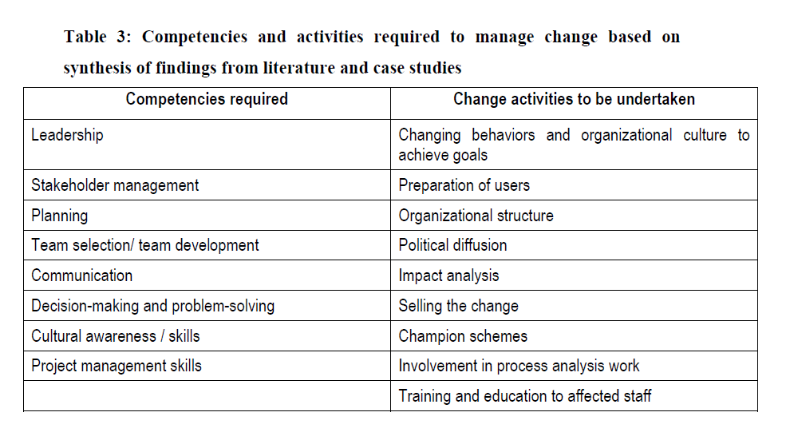
Figure 2: A starting point for a Change Manager job description? [Crawford and Nahmias (2010) Competencies for managing change]
And it was there where the meeting finished and where this report will finish too. As ever, the discussions were a mixture of the theoretical and the practical. And this brings to mind another quote (and one which has been attributed to everybody from Michelangelo to Einstein):

“In theory, theory and practice are the same. In practice, they are not”

Bennett, H. (2012) 'Pricing out Third Sector Organizations: The unequal outcome of the Freud Report' Conference paper presented at Social Policy Association Conference, University of York, 16th-18th July, 2012
Ibid
Bertram et al. (2014) Work Programme evaluation: operation of the commissioning model, finance and programme delivery
Riley et al (2014) Making the Work Programme work for ESA claimants, Centre for Economic and Social Inclusion
Macmillan et al (2013), The third sector in unsettled times: a field guide, Third Sector Research Centre
Ibid
Ibid
Ibid
Crawford and Nahmias (2010) “Competencies for managing change” International journal of project management 28 (4), 405-412
Ibid

