Practice Report: Teaching and Learning in Clinic

LAWYERING IN A DIGITAL AGE: A PRACTICE REPORT INTRODUCING THE VIRTUAL LAW CLINIC AT CUMBRIA
Ann Thanaraj & Michael Sales
University of Cumbria and Newcastle University UK.

Abstract
This practice paper offers a modest proposition that could make law graduates more capable of serving their clients in a modernised and efficient manner. We propose that in addition to law clinics and other forms of experiential activities, law schools could add a new type of clinical component to their curriculum that teaches students to use technology to assist in the delivery of legal services. Digital lawyering skills will help law students learn core competencies needed in an increasingly technological profession, and it may help close the gap between offering access to justice by making legal services available online in the most accessible and convenient way possible and in equipping law graduates with a modernised and digital legal education.

This is a practice report describing a new technological invention at the University of Cumbria Law department, and offers information on the reasons behind the creation and how it works. A research paper on the validity of this work, framing the learning outcomes in the context of clinical education and evaluating its effectiveness will be published in 2016.

A TECHNOLOGICAL INNOVATION IN CLINICAL LEGAL EDUCATION
The Cumbria Virtual Law Clinic (VLC) is an online clinic in partnership between students, supervising tutors and pro-bono solicitors in practice locally. The VLC has been designed to enhance the legal education of students through direct experience of legal practice using the medium of a virtual law office under supervision and also to provide a public service for people who need legal advice and representation but cannot afford to pay for it. In working on the VLC, students are expected to have the full responsibility of their cases, undertaking such tasks as legal research, corresponding, drafting statements of case, interviewing clients and expert witnesses and to undertake online dispute resolution on under tutor supervision. All of these activities, including managing their case and keeping time will take place on the VLC platform.
The theoretical framework adopts that of the intended learning outcome of clinical legal education, embedded through the pedagogy of collaborative experiential learning with the opportunity to reflect on the transactional learning experience to promote deep learning.
The virtual law clinic project has also been an opportunity for international collaboration as one of its earlier prototype was used in an international negotiation exercise between Cumbria and a German law school. A paper on the design of the then prototype and the learning outcomes from the international collaboration project will be published in 2016.
The design of the current VLC was completed in May 2015, and showcased in London, Berlin and Cumbria. After undertaking two pilot studies, the VLC has undergone a range of improvements and changes, taking on board feedback from law firms, student advisors and clients. A further pilot will be carried out by December 2015 with the aim of rolling out the VLC for full use by the public in April 2016. The current edition of the VLC prototype is accessible from www.cloudclinics.co.uk.
The intended learning outcomes of the VLC project are:
- To address the changes to the delivery of legal services
- Preliminary work is underway with the Law Society on developing the VLC
- Working with interested law schools to build a working group on
- Digital Lawyering in Clinical Education to share ideas and showcase how we can equip our graduates for the 21st century legal profession.
- To undertake and disseminate research in the field of digital clinical education
- With the aim of exploring, understanding and ascertaining the future of the delivery of legal services
- Examining its impact on the gap in offering a modernised legal education to meet the education and training needs for the future legal industry.
- Identifying whether digital lawyering is a key component of a modern legal education and if so, what this means and the sorts of curriculum that needs to be developed and embedded into law programmes
- To offer law students the opportunity to undertake digital lawyering experience
- Develop understanding and gaining experience in online dispute resolution for solving disputes, using the practice of digital lawyering skills and e-practice management,
- Gaining a realistic view of the future of legal services and the profession
- Develop understand the role of technology, privacy and security and how it affects legal ethics and constrains associated with this.
- Gaining transferable skills in maintain personal responsibility and accountability in both personal and group contexts online, working effectively with others online and undertaking decision-making in complex contexts.

CHANGES TO THE DELIVERY OF LEGAL SERVICES IN THE UK AND USA
There is a real need to provide our community, both locally and nationally with free and easily accessible legal advice. The VLC also offers our students the opportunity to engage with digital lawyering, the skills, experience and ethics involved in this method of delivering legal advice.
The Legal Services Act 2007 has sought to liberalise and regulate the market for legal services in England and Wales, to encourage more competition, facilitated by the creation and delivery of legal services though alternative business structures, thereby offering a more competitive and flexible approach to how legal services are being offered to clients. In a publication entailed ‘Legal innovation 2013 - New developments in an old profession’, Andrew Grech, the managing director of Slater & Gordon explains that ‘If we are looking to 2020 and 2030…I know there’s a big focus on online as a delivery system and of course that’s very important’. Similarly, the creator of the website Road Traffic Representation, an online legal service for those faced with prosecution for motoring offences, solicitor Martin Langan argues that ‘the big game changer is the power of technology to pull back the curtain of mystique…’
A similar change is taking place in the USA. Since 2010, the American Bar Association has set up a committee looking into proposing new approaches to the delivery of legal services and new ways of working. In 2014, The State Bar of Michigan discussed extensively on how technology, globalization, and other forces are transforming the ways legal services are accessed and delivered at its annual conference.
The concept of digital lawyering as a theoretical framework within legal education is a fairly new idea. There are still many unanswered question such as what does the legal professional need to know about how technology functions to be competent in the practice of law and what methods can we employ to educate law students entering a legal field which is technology-driven. In response to the impact of the Legal Services Act 2007, the research paper by the Legal Services Consumer Panel in November 2014 on ‘2020 Legal Services: How regulators should prepare for the future’ identifies that technology will go to the heart of all aspects of legal services in the future, changing how legal problems are identified, people and businesses resolve their disagreements, the way consumers choose providers, how legal services are delivered and law firms run their businesses.
We submit that the use of technology attracts little overhead cost, can streamline workflow processes and case management, improve efficiency and make easier the ethical and malpractice issues through automated built-in checks, whilst enjoying an expanded client base with a competitive advantage of easy accessibility and flexibility. Though this method of obtaining legal services, the public will benefit from greater access to services in our communities through collaboration between local organisations, pooling resources and streamlining referrals and communications. This would help ensure the people most in need of our services were able to be linked quickly with the organisation best able to provide it.
We also submit that our legal education system could do more to offer a modernised education which sets up law graduates as the future of the legal profession. It is now time for legal education to adopt technology as a necessary and vital part of learning to become a lawyer through the integration of apps such as the VLC and teaching about issues such as issues relating to security, management of data and privacy, alongside the experience of learning how to undertake lawyering on a digital platform. The VLC created in Cumbria takes this one step further to facilitate a client’s full legal matter to be handled through its virtual clinic.

HOW DOES THE CUMBRIA VLC WORK?
The VLC will aim to provide general information and initial advice on solving straightforward legal disputes. Students and clients are able to securely discuss legal matters online and handle the transactions of a physical law office within a secure digital environment. All aspects of the case including all aspects of managing the case will be recorded and archived. Each firm contains 4-6 students specialising in: Landlord and Tenant law, Family law, Employment law, or Consumer Protection and general contract law matters.
Clients will request legal assistance through the contact form on the client portal. Clients will need to provide information relating to themselves and their contact details. We appreciate that many clients are not technology literate and will need access to advisers on the telephone and documents in hard copy. The VLC sets out very clearly that all work on the case and all communications will take place virtually, and it is then for the client to decide if this manner of receiving legal services is something that is suitable for them. Terms and conditions will be available for reading and clients will need to click to accept before proceeding with making a request using clickwrap agreements. Clickwrap agreements are binding and enforceable contracts provided the user has continued access to the terms they are clicking to accept.
Tutors supervising the clinic will receive notice of a new registration and enquiry. Based on educational benefit, timescale and complexity of the request, tutors will approve or reject client requests within three working days of receiving the enquiry. If the enquiry is deemed to be unsuitable, the VLC will signpost another source of assistance. The VLC will run collaboratively with local firms, pooling resources and streamlining referrals and communications.
If accepted, tutors then add the approved user to the system. The client will receive a username/password combination and a link to the clinic. The student advisor/client relationship is formed through an agreement e-signed by both parties which sets out the scope of service, liability and timescale is clearly defined. The client will always have access to the terms and conditions of using the VLC service and the student advisor-client relationship agreement which they can refer to from the client portal.
The student providing legal assistance will then initiate contact with the client through a built in communication tool to introduce themselves and explain how their request will be handled. Tutors will supervise all work that is undertaken via the portal. Clients can request research and advice to be undertaken. All request sent to the clinic will be confirmed in writing. Case status will be updated when work is undertaken. Clients and advisors can communicate via built-in secure email within the clinic. If further discussions are required, the client and student can hold a video conference session within the client’s portal itself. This will be recorded and achieved for the client, tutor and student advisor to review where necessary.
Once an appointment has been arranged for a detailed discussion, the client will be interviewed by two student advisors from the University and a volunteer lawyer from a law firm via the VLC’s communication tools. Clients will need to upload all the relevant documents for the interview. All communications between the client and the advisors will be undertaken through the secure and encrypted portal with the strictest confidence. In addition to providing legal advice, student advisors will write letters and otherwise communicate with others on the client’s behalf.
The legal assistance that will be provided includes legal advice, writing letters, speaking to relevant authorities or opponents, negotiating settlements to disputes, and representation in the courts. Work undertaken by the student advisors under supervision will be free of charge. However clients may still need to pay their own legal expenses, such as the cost of instituting proceedings, or other expenses, such as getting to court.
Any documentations written or provided during this process is uploaded to the secure document repository within the clinic group. It is possible for the client and student to feed back to each other’s submissions using the commenting feature. All matters are recorded for training and auditing purposes. The security used in a VLC is the same high-level technology used by online banking to protect the information being exchanged. Documents stored by the firm in a VLO are protected by this level of security and are accessible anywhere as long as there is access to the internet.
Once the matter has closed, the client and advisor will sign an agreement to bring the representation to a close. The case will be archived and is available for the client and advisor to request access. The client will be provided with a digital encrypted version of their file for download and printing.
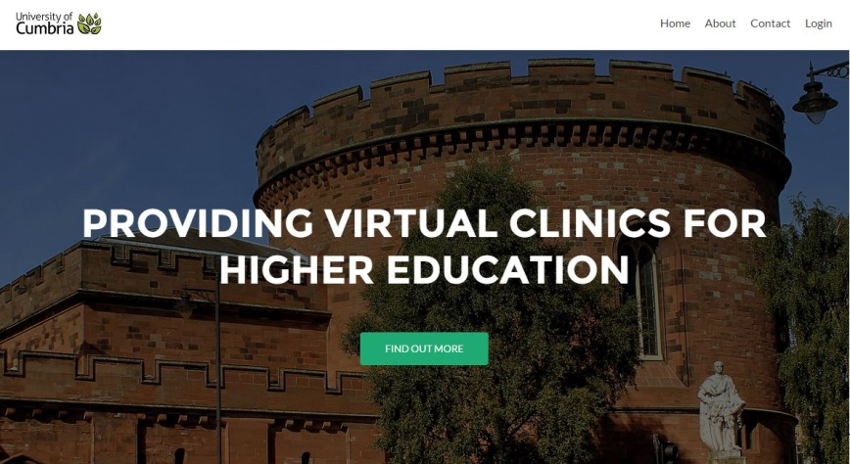
Figure 1: Virtual Law Clinic homepage

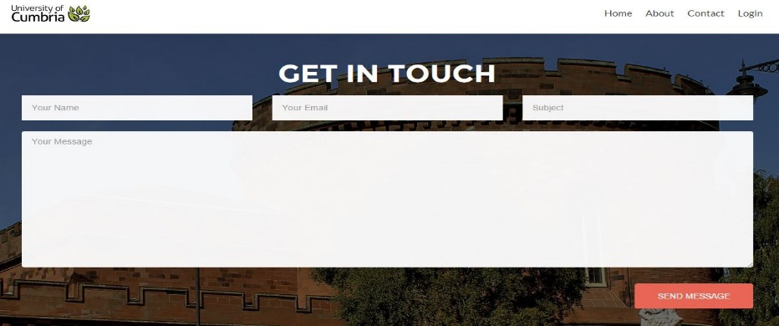
Figure 2: Client contact form

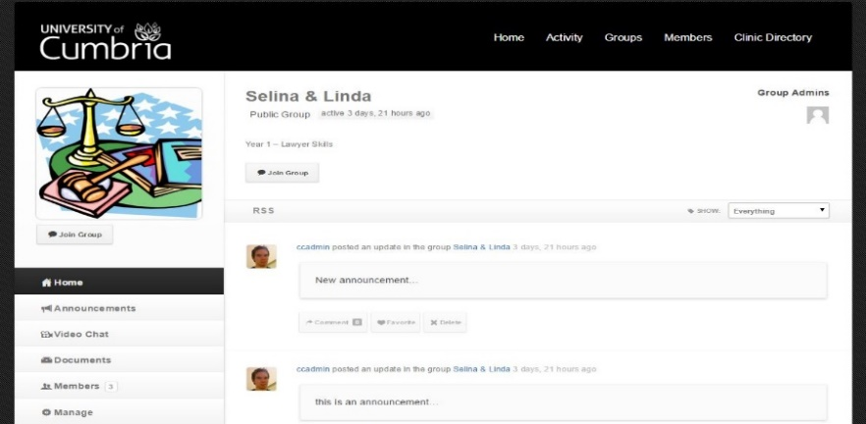
Figure 3 Group collaboration page

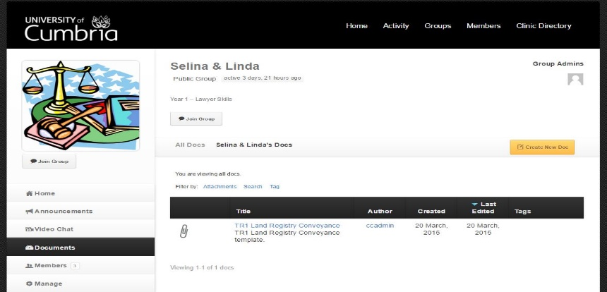
Figure 4: Process management and document system

THE DESIGN PRINCIPLES OF THE CUMBRIA VIRTUAL LAW CLINIC
Our intention was to create a secure platform which enabled new ways to communicate and collaborate with clients, supervising tutors and pro-bono solicitors, produce documents, settle disputes, interview clients, and fully manage client’s cases online using suitable and secure electronic tools and techniques. The prototype that is currently designed has the ability to encompass the entire process of working with a client online from the start of the client-advisor relationship until the end of the case. It is bound in the real world by the jurisdiction of English law, expecting student advisors to demonstrate a high standard of care and demands close attention to compliance with the rules of professional responsibility, as they would in a traditional law clinic environment, supported with features for efficiency and compliancy such as keeping to limitation periods and deadlines with built in calendar and reminder notifications.
A full research paper which is forthcoming in 2016 will provide a detailed evaluation of the pedagogical benefits of a VLC, drawing upon the already well-established theory of clinical legal education and various pilot studies which have been conducted through this medium in testing the system.
Nevertheless, the VLC encompasses experimental learning, generating confidence in students as their success is determined by their own efforts, allowing for detailed application of knowledge, reflection and self-examination. It gives students the opportunity to explain why they are taking certain actions and they are able to discuss and reconsider their actions. Students can examine the legal and social issues in some depth, developing and acquiring improved skills in research, communication, interviewing, drafting, negotiating, and problem solving. Further, the work undertaken through the VLC platform allows awareness of ethics and the professional responsibility and conduct of lawyers, whilst understanding the problems of different generation and background. This experience can add to their understanding of the position of others in society, and can increase their maturity and sense of responsibility. Most importantly however, it equips students for the changes that is to come in future years in the delivery of legal services, using alternative cost-effective means, affordable and accessible for clients.
Given the rate at which technology evolves, and from the pilot studies we are undertaking, we believe that the features of the VLC will continue to expand to provide additional communication and security features.

Clinical legal education utilizing experiential learning of advising clients and dealing with all aspects of cases under supervision
Using technology and online delivery to offer accessible and efficient legal service
Clinical legal education – experiential and real practice of the law under supervision

Digital lawyering - encompasses all the methods that a lawyer may use to practice law online, from the delivery of legal services online, collaborating and communicating, providing legal advice and dispute resolution online, including interviewing, investigating and advocacy

Digital lawyering –
encompasses all the methods that a lawyer may use to practice law online, from the delivery of legal services online, collaborating and communicating, providing legal advice and dispute resolution online, including interviewing, investigating and advocacy

Figure 5: Merging technology with clinical legal education

A practical and secure client enquiry system, with built in jurisdiction and conflict of interest checks
A process management and workflow system that ensures that administration of cases are dealt with automatically and efficiently.
Digital lawyering - encompasses all the methods that a lawyer may use to practice law online, from the delivery of legal services online, collaborating and communicating, providing legal advice and dispute resolution online, including interviewing, investigating and advocacy

Ability to communicate with clients, student advisors and supervisors via recorded text-based, audio and video conferencing
A fully secure and encrypted client portal for clients to receive updates on their case, communicate securely and review all work undertaken through the recording function

Figure 6: Features of a functioning and secure VLC

We began the project by considering the following factors:
- Software and application framework
  - Identifying and exploring the viability of various types of technology, software and application frameworks which will be relevant to design and function of a virtual law clinic
  - Questioning and determining how will the technology allow document automation and management, collation of client data, automated timesheets and calendar notifications and how clients and student advisors can utilize a variety of communication methods through the platform?
Our options were to use already available application frameworks as a backbone to creating a VLC
We reviewed the use of Blackboard and found that it had an intuitive interface and it was a familiar platform to many universities, students and easy to navigate for clients. However the standard version of Bb Learn did not have collaborative tools or document management and upgrading it to a premium version was expensive for a pilot project. We also reviewed Moodle, which is another learning management framework used by many universities. We found that it was open source with an active developer community which made the development and administration of the software more supportive. However it was an unintuitive system with a slightly outdated interface and difficult to administer for the purposes of a VLC and the complexity and functionality required.
Next we reviewed WordPress, which is widely known for its blogging functions. It is open source with a very active developer community offering a large library of plugins and themes for customisation and adaption. Because of the nature of WordPress and the large array of possibilities it offers in terms of what it can be used for it requires regular maintenance. We settled on WordPress, thanks to no costly subscription fees for document management and collaboration features, its readily available plugins for many required features, ease of use for clients, students and tutors, straightforward administration and upgrade procedures and its ability to rapidly develop new features.
We configured WordPress to support multiple sites. Each site refer to a ‘clinic’ and administering and developing the technicalities behind it allowed for a highly scalable development with any number of clinics and users. Within WordPress, we utilized a plugin application called BuddyPress. This is a collection of collaboration tools for WordPress. We have created groups to organise participants within a clinic, messaging component allows user-to-user communications, BuddyPress Docs for document management (allows users to upload, share and store revisions of materials), Bastri for real-time video conferencing and BuddyPress Group Email Subscription plugin used to notify participants of activity within clinic groups and to ensure the efficient management of each case within appropriate deadlines.
- Building the Virtual Law Clinic exterior interface
  - We discussed with student advisors, pro-bono solicitors and law firms on what the look and feel of the VLC platform should be and what it should be capable of performing. We drew up a list of the case management protocol as a starting point.
  - The VLC had to be capable of managing enquiries from clients and the workflow process of how the enquiry reaches the clinic and then determine what happens once a case is taken on, such as the automated built-in checks on jurisdiction, applicable law, conflict of interest and so on.
We have designed the VLC platform to allow tutors the flexibility to adapt to colour schemes, themes, university logo and image branding and an array of widgets useful to a clinic to display in the footer or side bar of each clinic. Each clinic template is highly customisable. We wanted an easy to navigate through site content, one which is not overwhelming with too many design features that is distracting. Tutors can quickly create new clinics using a bespoke administration tool. The clinics may be archived once complete. During administration upgrade, there will not be any disruption to the clinics or the materials held within it. Apart from mimicking the reality of a law firm, we also wanted the VLC to provide the sorts of content that will be educational for the public
In order to ensure that all clients are aware of how the VLC functions and how it works, information within the VLC is laid out upfront with the necessary information and advice relating to jurisdiction, that the legal services provided will be purely online only and the turnaround time for handling enquiries. Liability clause, terms and conditions, disclaimers, client-advisor agreements are made available on all pages of the platform for clients and potential clients to review at any time.
We have undertaken rigorous testing of the functionality of the platform including its security, efficiency and accessibility through two pilot projects involving 3 student advisors, 2 supervising tutors and 2 clients in each pilot. A third pilot involving a law firm will take place in December 2015 to ensure that the client’s portal facilitates client’s needs and expectations followed by making revisions to the portal after pilot feedback.

- Design and function of the internal site – the client portal
  - After a number of consultations with various law firms and student advisors, we came up with a list of design principles for the client portal and what it should be capable of doing.
  - A priority was the security, confidentiality and encryption of the portal
  - Features of the portal such as communication tools, updates and progress on case, ability to contact student advisors, uploading and downloading of documentations were key design and function features
Having made an enquiry using the VLC enquiry form, and this being reviewed by the supervising tutor and accepted as a matter that will be dealt with by the VLC, the client is provided with a unique login combination which will allow access into the client’s bespoke portal. When the client logs in, they will be taken to their own portal. It is the primary feature of the VLC that facilitates the delivery of the online service.
The portal also includes built-in communication functions multiple-way communications between the client, advisor, supervising tutor and others. The communication options are by written correspondence on the portal, audio or video conferencing. No special software is required. The client will require either a mobile phone or personal computer or portal electronic device with a camera. It is through this platform that the client and student advisor will communicate, exchange documentations, hold audio and video conferencing and obtain advice. The platform and its functionality is encrypted to keep the information secure.
Once client-advisor relationship is formed, the client will always have access to their case files and documentations either uploaded by the client or those prepared by the advisors. These are available for reviewing online, feedback and commenting. The portal also consists of reminders and basic guidance for clients on protecting their computers, backups, keeping their login details secure and security issues and reminders. Tutorial have also been created to help clients navigate through the VLC and client portal. Educational publications are also made available for useful general knowledge on legal updates.
Inside the portal, each communication between the client and lawyer is recorded and stored within the client’s portal space with a date and time of when the communication took place. Documentations will contain information of when it was uploaded, when work was undertaken on it, when it was last edited and by whom. Clients will not be able to delete or amend any information. All the data stored will remain on the hosted system and are subject to regular backups
We thought that prospective clients may benefit from watching a short five minute tutorial video that explains the firm’s online legal services or how to register for an account and request legal assistance.
Before the client can access the full function of the client’s portal, the client is required to undertake a registration process which requires a completion of personal details, address and employment history. The client will then need to read and accept each of the terms and conditions of the client-advisor services using a clickwrap agreement process. In the terms and conditions of service we have included information on liability, disclaimers, nature of the service provided, the methods of communication available, the storage and return of client’s data and the recording of all transactions which take place on the portal.
We will also request that the client uploads two sets of identification documents to the portal with a signature to confirm their identity. It is after this process that the client will be able to access the full portal and begin work with the student advisor and supervising tutor.

CHALLENGES IN DESIGNING A VIRTUAL LAW CLINIC

A case of mistaken identity
When we undertook focus groups to determine what the client portal should be able to do, we came across a number of misunderstood functionality of a VLC. We found out that a VLC is mistaken to be a simulated clinic. Some thought that it was a platform to download forms and brochures about the law. Although we will be working on developing a section on publications with updates on the law, this is not the sole purpose of the VLC. Some also though that it was possible to submit an enquiry but also meet the advisors in person. It is only possible to contact the members of the VLC via the built-in enquiries form on the site, and the conversation between the client and advisor takes place via video conferencing through the secure client portal. Our terms and conditions and information for clients section on the portal has addressed all of these mistaken identity factors.

Managing expectations
We wanted to develop a system that was client-friendly ensuring that the needs of the client is taken care of both by the advisors and the functionality of the system itself. We have revised this numerous times to allow the system to automate responses efficiently whenever a client or prospective client gets in touch. For example, we formulated a simple automated response to prospective clients who make an enquiry using the built-in contact form.

‘Thank you for your enquiry to the Cumbria Virtual Law Clinic. We will get in touch with you within three working days. If we are unable to assist you we will offer you some assistance in finding a suitable law firm at the soonest’.
When work is undertaken on a client’s case, the client will be notified.
‘We are working on your case and an update on the progress of work will be made available to you in your portal at the end of the working day. Please access the client portal with your secure login details to review and update any requests’.
In order to ensure that the client is always aware and reminded of how the VLC functions, the terms and conditions, associated disclaimers and liability clauses are also set out on every page of the client’s portal for convenient reference.

RECOMMENDATIONS FOR SECURITY AND SENSITIVE DATA MANAGEMENT
Student advisors, supervising tutors and clients must be educated about security threats when practicing on remote devices and how to mitigate those risks. This will form part of the introductory module to Digital Lawyering skills. Clients and everyone using the VLC will need to be reminded that any data held on portable devices such as mobile phones, laptops and other handheld devices are sometimes not encrypted and the data can be accessible widely. If devices are stolen or misplaced, sensitive and confidential legal matters would be vulnerable. Even if data is backed up, the information in the devices can be misused.
The Law Society is yet to comment on the intricacies, formalities and ethical constrains of different ways of working, especially in the delivery of online legal services. Thus, as a reference point, this paper will refer to the American Bar Association as a benchmark on good practice for the VLC development. In 2008, the Association of the Bar of New York Committee on professional and judicial ethics, gave their formal opinion suggesting that the lawyer must take affirmative action to preserve any digital communication regarding the representation that may otherwise be deleted or lost from their digital filing system. This includes discussing storage and retrieval of electronic data and documents at the beginning of client representation. Similarly, in 2009, the Arizona state bar stated that lawyers may store law office data online and use a system that allows their clients to access the information online as long as the lawyer takes ‘reasonable precaution’ to safeguard the security of that confidential information.
Using the advice given by the ABA, we translate the expectations of safe handling of data into the following practical tips to ensure secure storing and access of data:
- Full disk encryption on the hard drive
- Avoid free wifi hotspots as these are shared public access points, sometimes with open access
- Ensure that the data stored is hosted on a server that the organisation controls and has access to, rather than a third party.
- Only the client and advisor and relevant supervising tutors should have access to the client information.

REACTIONS FROM PILOT STUDY
Having conducted two pilot studies, here are some of the reactions of students and a client having completed a full case on the Virtual Law Clinic.
Jim, a final year student on the LLB programme was a student advisor on this matter. He said
“I couldn’t believe what we have here at Cumbria. This is quite a cool idea and really innovative! So we had some training on how to use the VLC – straightforward. I knew what to expect from working in law firms – the same process but online. In fact this time it was easier. The system managed a few aspects of timesheets and deadline updates automatically…

… Today, we received our first enquiry, an Employment law matter. I was amazed at how the VLC could automatically assign the cases to the respective firms. The enquiry after being approved by my tutor, just popped up on the Employment law clinic inbox. Everything we were doing on the firm, including talking to each other was automatically recorded. My tutor could check everything we were doing, and that made me feel more relaxed…

…The video conferencing interview was so different to what I was used to. There were no problems in using it though and the client was really pleased she could see us and the conversation went very well. But I think it takes some getting used to not speaking face-to-face. My tutor has plans of using this to collaborate with law schools across the UK and Europe. I am really excited to have some international experience in my studies”.

Sophie, is also a final year student and was an advisor on the Employment law matter. She said
“… My tutor mentioned digital lawyering – I never thought I would hear that in a small law school – and I am so glad that we are learning about how to run cases online…

…I undertook some work experience in New York last summer and a few attorneys were discussing a shift towards online legal services….

….I loved the experience from the exercise with the client we just completed on the virtual law clinic and I can see this catching on”.

Holly was our employment law client. She is also an employment lawyer by profession. She agreed to try out the VLC as if she was a client with the aim of exploring its potential in her own practice. She said
‘I completed an enquiry form and within an hour it generated a secure login ID. I logged in a few hours later and found out that my case has been accepted by one of the firms. I was sent an automatic document explaining the how confidentiality and the security of the system worked. I felt this is the same as online banking, so didn’t worry about it…

….I think the students at Cumbria are fortunate to be getting hands on real life experience of digital lawyering and how legal service can be delivered using technology…With online consultations in law already becoming the norm in America, I think the VLC allows students to learn all about practice and challenges of online law practice…

…The software is really well designed and I felt very happy and comfortable. I would recommend this to others who may need some free legal help…

FUTURE DIRECTION OF THE DIGITAL LAWYERING PROJECT

Phase 5  January-March 2016 | Client videos and pilot 3 | To develop further short video clips and factsheets to make legal advice more accessible to clients. These will be made available by students under supervision.  - A final pilot study will take place before the clinic is fully rolled out at university.  - Commencing work on funding application to the EU
 | Promoting the services of the clinic | Requiring advice on how best to market the virtual law clinic. Our clients include new businesses, and clients requiring advice on housing and employment law.
Phase 6  February-April 2016 | Implemented in curriculum | Students will now being advising clients using the virtual law clinic. Aim is to provide access to justice to those who otherwise cannot access and afford legal advice. We will be working with local businesses and start-up enterprises on offering advice on Intellectual Property, Employment law or housing law matters.  Selection of clients criteria include:  - The educational benefit of the legal issue for students  - Capacity and expertise to deal with enquiry  - No conflict of interest in line with professional obligations  - Indemnity insurance  - Opening hours and term-time limits on clinic
Phase 7  March 2016- May 2016 | Showcasing and training to members of staff at Cumbria | Encouraging members of staff at UoC to undertake experiments and pilot studies using the virtual clinic for their own programmes. Lunch time training events and showcases will be held
Phase 8  Summer 2016 | Hosting a  Digital Lawyering national conference:  D-CLE | Digital Clinical Legal Education - Law Schools will be invited to participate in a one day workshop at Cumbria on digital lawyering skills and how best to educate our students for the changing future of the delivery of legal services. Conference planning is underway.  - Creating a community of practice to influence the Solicitors and Barristers Authority in the UK to understand the need to modernise legal education – a scoping paper will be provided.
Phase 9  July-August 2016 | Showcasing the VLC and its functionality | - At various conferences  - Research papers
Phase 10  September 2016-September 2017 | Research projects  And ongoing implementation into law curriculum | Aim: To bring about a modernised legal education  This platform can be used by the wider university for further research and initiations for funding  - Initiating research projects on digital lawyering in curriculum  - Changing policy on legal education – equipping for digital delivery, legal ethics for online advice, what this means to legal education?
Phase 11  September 2016-September 2017 | Added value and wider dissemination | The virtual law clinic will form a key part of the teaching and assessment tool across all law programmes, both UG and PG offered in Cumbria starting in September 2016  Setting up International collaborative partners  Further workshops on digital lawyering  - Thought leadership aimed at changing thinking about legal education  - Rolling out the virtual clinic to interested institutions and law practice firms
FUTURE RESEARCH
As part of the project aims, we are intending to undertake some detailed research into how legal education can be modernised and aligned to the new developments and future trends of the profession. We aim to explore the changing policy on legal education, equipping for digital delivery, legal ethics for online advice, what this means to legal education.
We will focus on:
- What innovations are currently underway in law school curriculum to address the competency requirements of digital lawyering?
- Addressing the ethical constrains of delivering legal services online
In addition to research projects, we will be hosting a Digital Clinical Legal Education one day conference at Cumbria to disseminate further details of our upcoming pilot study and to demonstrate the full working of the Virtual Law Clinic project. We would be extremely keen to hear from interested law schools to work with us or to utilize this platform in their own curriculum.

References
- Legal Services Act 2007, accessible at http://www.justice.gov.uk/publications/legalservicesbill.htm
- Legal innovation 2013 - New developments in an old profession’, Baker Tilly publications
- Legal Services Consumer Panel in November 2014 on ‘2020 Legal Services: How regulators should prepare for the future’, accessible at: http://www.legalservicesconsumerpanel.org.uk/publications/research_and_reports/documents/2020consumerchallenge.pdf

The ABA’s Commission on the Future of Legal Services, accessible at: http://www.americanbar.org/groups/centers_commissions/commission-on-the-future-of-legal-services.html

The ABA’s Commission on the Future of Legal Services, ‘The Future of Legal Services: Changes and Challenges in the Delivery of Legal Services’ November 10, 2014, State Bar of Michigan, accessible at: http://www.michbar.org/file/generalinfo/pdfs/FutureReport.pdf
- The ABA of the city of New York opinion on digital lawyering and ethics Accessible at: http://www2.nycbar.org/Publications/reports/show_html_new.php?rid=794
- Kunz et.al, ‘Click-Through Agreements: Strategies for Avoiding Disputes on Validity of Assent’, accessible at: http://www.steptoe.com/assets/attachments/2353.pdf
- Gupta, I, ‘Are websites adequately communicating terms and conditions link in a browse-wrap agreement?’, European Journal for Law and Technology, Vol. 3, No. 2, 2012 accessible at http://ejlt.org/article/view/47/239.
- Unfair Contract Terms Directive, Council Directive 93/13/EEC of 5 April 1993
- IT Consumer Contracts Made at a Distance – Guidance on Compliance with the Distance Selling and Unfair Terms in Consumer Contracts Regulation, Publication no.672 (Dec. 2005), available at http://www.oft.gov.uk/shared_oft/reports/consumer_protection/oft672.pdf
- The State Bar of Arizona Ethics Opinions: Confidentiality; Maintaining Client Files; Electronic Storage; Internet, Rule 1.6a accessible at: http://www.azbar.org/Ethics/EthicsOpinions/ViewEthicsOpinion?id=704

Ann Thanaraj is Principal Lecturer at Cumbria University and Michael Sales is a software developer with over 10 years’ experience in public and private sector roles, currently working at Newcastle University providing web and collaborative development support to the university research community.
The Clinical Legal Education is a term which encompasses learning which is focused on enabling students to understand how the law works in action. This can be done by undertaking actual cases or realistic simulated case work. Leaders in the field of Clinical Legal Education have written substantially on this area including Kerrigan K., and Murry, V ‘A student guide to Clinical Legal Education’, Palgrave (2011); Hall, J and Kerrigan K (2011) Clinic and the wider law curriculum. International Journal of Clinical Legal Education, 15-16. pp. 25-37; Gold, N., Nurturing professionalism through Clinical legal education, for the International Journal of Clinical Legal Education and European Network for Clinical Legal Education Joint Conference, Olomouc, Czech Republic (2014)
The philosophy behind transactional learning was created by Paul Maharg in Maharg, P (2004) Virtual communities on the web: transactional learning and teaching, in Aan het werk met ICT in het academisch onderwijs, Vedder, A. (Ed),Rotterdam: Wolf Legal Publisher, and it was then discussed further in Maharg P, (2006) Authenticity in Learning: Transactional Learning in Virtual Communities, Journal of Information, Law and Technology (JILT). Transactional Learning is defined as learning activities and opportunities that exhibit the following design characteristics: - Active learning; - The practical realities of transactions forming the basis of learning - Opportunities to reflect on learning; - Collaboration (both within and across teams - Process, or holistic, learning. - Immersion in professional role-play - Task authenticity
Thanaraj, A., Internationalizing Education: Evaluating the growth of intercultural communication and competency in students through an international negotiation project using an online law office, Journal of Pedagogic Development, 2016, forthcoming.
Legal Services Act 2007, accessible at http://www.justice.gov.uk/publications/legalservicesbill.htm
Grech, A., (June 2013) in ‘Legal innovation 2013 - New developments in an old profession’, Baker Tilly publications
Langan, M., (June 2013) in ‘Legal innovation 2013 - New developments in an old profession’, Baker Tilly publications
The ABA’s Commission on the Future of Legal Services, accessible at: http://www.americanbar.org/groups/centers_commissions/commission-on-the-future-of-legal-services.html
The ABA’s Commission on the Future of Legal Services, ‘The Future of Legal Services: Changes and Challenges in the Delivery of Legal Services’ November 10, 2014, State Bar of Michigan, accessible at: http://www.michbar.org/file/generalinfo/pdfs/FutureReport.pdf
Legal Services Consumer Panel in November 2014 on ‘2020 Legal Services: How regulators should prepare for the future’, accessible at: http://www.legalservicesconsumerpanel.org.uk/publications/research_and_reports/documents/2020consumerchallenge.pdf
The Law Society is yet to comment on the intricacies, formalities and ethical constrains of different ways of working, especially in the delivery of online legal services. Thus, as a reference point, this paper will refer to the American Bar Association as a benchmark on good practice for the VLC development. The ABA of the city of New York gave a formal opinion in 2008 stating that ‘A lawyer’s ethical obligations to retain and to provide a client with electronic documentation relation to a representation’. In practical terms this relates to the need for the lawyer must take affirmative action to preserve any digital communication regarding the representation that may otherwise be deleted or lost from their digital filing system. Accessible at: http://www2.nycbar.org/Publications/reports/show_html_new.php?rid=794
Accepting terms and conditions in a client-advisor agreement for example using clickwrap agreements is a common method of clicking to accept the terms of agreement. These methods are commonly used in internet banking, social media, or when purchasing items. The application and critical discussions surrounding online contracts and viability of clickwrap agreements in the US is discussed by Kunz et.al in ‘Click-Through Agreements: Strategies for Avoiding Disputes on Validity of Assent’, accessible at: http://www.steptoe.com/assets/attachments/2353.pdf and also by Gupta, I, ‘Are websites adequately communicating terms and conditions link in a browse-wrap agreement?’, European Journal for Law and Technology, Vol. 3, No. 2, 2012 accessible at http://ejlt.org/article/view/47/239.
In England, the Unfair Contract Terms Directive, which applies to all consumer contracts whether online or offline, requires Member States to “ensure that contracts concluded with consumers do not contain unfair terms.” (Council Directive 93/13/EEC of 5 April 1993 on unfair terms in consumer contracts). Specifically relevant to internet contracts, the directive provides: “A contractual term which has not been individually negotiated shall be regarded as unfair if . . . it causes a significant imbalance in the parties’ rights and obligations arising under the contract, to the detriment of the consumer.” (Article 3.1) The Acts allow for direct enforcement action by the consumer and also empowers the Office of Fair Trading and other regulatory bodies to seek enforcement through the courts. See IT Consumer Contracts Made at a Distance – Guidance on Compliance with the Distance Selling and Unfair Terms in Consumer Contracts Regulation, Publication no.672 (Dec. 2005), available at http://www.oft.gov.uk/shared_oft/reports/consumer_protection/oft672.pdf
The current edition of the VLC prototype is accessible from www.cloudclinics.co.uk
Encryption is a process in which the data is converted into a state using an algorithm that is not readable without a key to decrypt it. Information on the use and method of encryption can be accessible at: http://searchsecurity.techtarget.com/definition/encryption
This is in compliance with the application of IT Consumer Contracts Made at a Distance – Guidance on Compliance with the Distance Selling and Unfair Terms in Consumer Contracts Regulation, Publication no.672 (Dec. 2005), available at http://www.oft.gov.uk/shared_oft/reports/consumer_protection/oft672.pdf
The ABA’s Commission on the Future of Legal Services, accessible at: http://www.americanbar.org/groups/centers_commissions/commission-on-the-future-of-legal-services.html
State Bar of Arizona Ethics Opinions: Confidentiality; Maintaining Client Files; Electronic Storage; Internet, Rule 1.6a accessible at: http://www.azbar.org/Ethics/EthicsOpinions/ViewEthicsOpinion?id=704

