The Community Order and the Mental Health Treatment Requirement
Linda Seymour, Max Rutherford, Husnara Khanom, Chiara Samele1
Introduction2
Just a few months into 2008, a convergence of unfortunate circumstances has brought the plight of offenders with mental health problems into sharp focus. Figures released by the Ministry of Justice showed there were 92 apparently self-inflicted deaths among prisoners in England and Wales in 2007, compared with 67 in 2006.3 This 37% increase in suicides in prison has been associated with the overcrowding that has continued inexorably. Indeed towards the end of February the population of offenders in the prison estate rose above the critical 82,000 mark for the first time.4 The Home Office has predicted that the prison population could rise to 101,900 by 2014.5
As can be seen from Table 1, reviews have found a high prevalence of mental illnesses among prisoners in England and Wales. 6,7,8,9
Table 1: Mental health problems in prisons and the general population
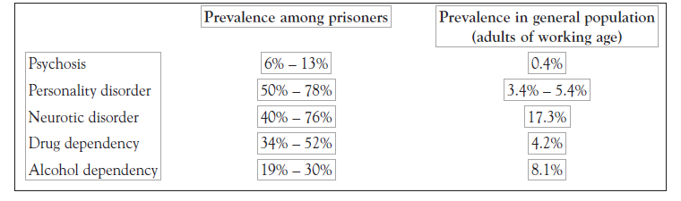
The Government has acknowledged that too many people with mental health problems continue to be imprisoned10, particularly as the mental health care provided in prisons is often poor.11 However mental health problems are also common amongst people receiving community sentences. According to the national risk/needs assessment tool for adult offenders in England and Wales, the Offender Assessment System (OASys), the level of emotional needs that may have been directly related to the criminal behaviour of those serving community sentences in 2005/6 was 43 per cent.12 Supervised women offenders appear to have higher levels of mental health need than men. A national study in 1997 found that a third of women subject to community supervision by the Probation Service described themselves as having a mental disorder. During the same period the figure for men was one in five.13
Levels of mental health need for offenders managed in the community appear to be increasing. In 2002 a review of work in Inner London Boroughs found that at least 20 to 30 per cent of individuals in touch with the Probation Service displayed evidence of a mental disorder.14 By 2006 further research demonstrated that 48 per cent of those in contact with the Probation Service were experiencing mental health concerns and as many as a third of offenders in the community also suffered from problems associated with a personality disorder.15
The number of people receiving community sentences has increased in parallel with the rising numbers in the prison population. For example, in the decade between 1995 and 2005 the number of people sentenced to community sentences (repackaged as Community Orders16 in April 2005 as part of the implementation of the Criminal Justice Act 2003), rose by nearly 74,325, to 204,247 during 2005.17
In April 2005, the Community Order became the new generic community sentence available to magistrates and judges as an alternative to prison, when a fine or a discharge is deemed inappropriate.
The Community Order utilises a choice of twelve different requirements including unpaid work, electronic curfew, supervision, and drug and alcohol treatments. One of the twelve is the Mental Health Treatment Requirement (MHTR) which can be issued to offenders who have an identified mental health problem; where treatment is readily available; and when the offender has given their consent. Despite the high levels of mental health problems among offenders serving sentences in the community, the MHTR has been used in less than one per cent of all requirements issued. Only 725 were issued in England and Wales in 2006, out of a total of 203,323 requirements.
This article gives an overview of the MHTR and its use within the context of community sentencing and the Community Order. Various hypotheses are posited that might explain the low uptake of the MHTR by sentencers. We conclude by describing the Sainsbury Centre’s research programme on the MHTR and describe the pilot phase of the research.
Community sentences overview
Since the Probation Service’s inception in 1907, community sentences have been renamed and reconfigured many times, most recently in 2005. Table 2 summarises how the sentences have developed.
Table 2
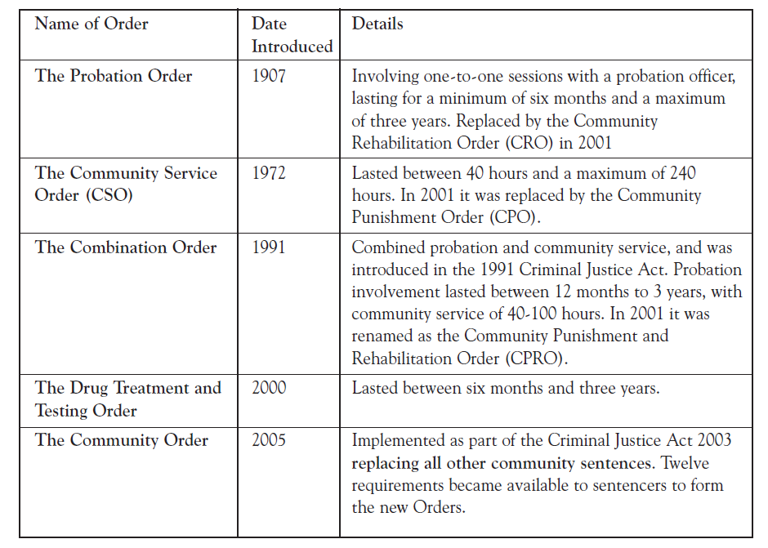
Over a 10-year period up to 2005, the number of people given community sentences increased by more than 74,000, representing a rise of 57 per cent. The largest proportion of offenders given community sentences committed an offence type of other summary offences, theft, or summary motoring.18
The Community Order

In April 2005, as part of the implementation of the Criminal Justice Act 2003, the community sentence was re-launched as the Community Order and since that time has been used for all offenders given community sentences.19
The new Order offered sentencers more flexibility and choice when assigning a community sentence to an offender. Court disposals could be adapted more closely to the needs of the offender and community while applying the sentencing principles of punishment, rehabilitation, reparation and public protection more effectively. The twelve possible requirements allowed by the Community Order invited a hybrid approach to community sentences, with requirements issued in proportion to the seriousness of the offence. The overarching aim of this new approach was to increase public confidence in community sentences.
The twelve requirements
The table below describes the main elements of the twelve requirements available for sentencers when constructing the Community Order.20, 21
Table 3: The 12 requirements of the Community Order
Requirement | Serving hours demanded | Details
- Unpaid work | 40-300 hours | An Unpaid Work Requirement must be completed within 12 months. It involves activities, such as cleaning up graffiti, making public areas safer or conservation work. The work is intended to benefit the local community and often residents are able to suggest projects for offenders on Unpaid Work to carry out.
- Supervision | Up to 36 months | An offender will be required to attend appointments with an Offender Manager or Probation Officer. The focus of the supervision and the frequency of contact will be specified in the sentence plan based on the particular issues the offender needs to work on. The length of a Supervision Requirement must be the overall period for which the Community Order is in force.
- Accredited programme | Length to be expressed as the number of sessions; must be combined with a Supervision requirement | These are aimed at changing offenders’ thinking and behaviour. For example, the Enhanced Thinking Skills Programme is designed to enable offenders to understand the consequences of their offence, and to make them less impulsive in their decision-making. This requirement is particularly intended for those convicted of violence, sex offending, drug or alcohol abuse, domestic violence and drink impaired driving.
- Drug rehabilitation | 6-36 months; offender’s consent is required | If offenders commit crime linked to drug abuse, they may be required to go on a Drug Rehabilitation Programme. Programmes may involve monthly reviews of an offender’s progress.
- Alcohol treatment | 6-36 months; offender’s consent is required | This requirement is intended for offenders whose crime is linked to alcohol abuse and treatment.
- Mental health treatment | Up to 36 months; offender’s consent is required | After taking professional advice, the court may decide that the offender’s sentence should include mental health treatment under the direction of a doctor or psychologist.
- Residence | Up to 36 months | An offender may be required to live in a specified place, such as in a probation hostel or other approved accommodation.
- Specified activity | Up to 60 days | Including community drug centre attendance, education and basic skills or reparation to victims.
- Prohibited activity | Up to 36 months | Offenders may be ordered not to take part in certain activities at specified times, like attending football matches. If offenders do not comply with this Requirement, they can be sent back to the courts for re-sentencing.
- Exclusion | Up to 24 months | An offender may be prohibited from certain areas and will normally have to wear an electronic tag during that time.
- Curfew | Up to 6 months and for between 2-12 hours in any one day; if a standalone curfew order  is made, there is  no probation  involvement and is  privately contracted | An offender may be ordered to stay at a particular and for between location for certain hours of the day or night. Offenders will normally wear an electronic tag during this part of their sentence.
- Attendance | 12-36 hours with a maximum of 3 hours per attendance | For offenders under 25, the court can direct the offender to spend between 12 and 36 hours at an attendance centre over a set period of time. The offender will be required to be present for a maximum of 3 hours per attendance on each occasion. The attendance centre Requirement is designed to offer ‘a structured opportunity for offenders to address their offending behaviour in a group environment while imposing a restriction on their leisure time’

The Home Office has mapped the twelve requirements against their intended effects of:-
- Punishment: Offenders should be properly punished for their crime and a lengthy, well-planned and properly supervised community sentence is tough on offenders and offers far more constructive possibilities for the future.
- Reparation: Offenders may be required to face their victim or give back to their local community, which can facilitate their viewing their crimes in a different way.
- Rehabilitation: Offenders need support and opportunities to change to deter them from committing more crimes.
- Protection: Protecting the public is the top priority.

Table 4: Requirements and their intended effect (Home Office 2005)

Requirement | Punishment | Reparation | Rehabilitation | Protection
Unpaid work | P | P | P
Supervision |  |  | P
Accredited Programme |  |  | P
Drug Rehabilitation |  |  | P
Alcohol Treatment |  |  | P
Mental Health |  |  | P
Residence |  |  | P | P
Specified Activity |  | P | P
Prohibited Activity | P |  |  | P
Exclusion | P |  |  | P
Curfew | P |  |  | P
Attendance Centre | P

The Mental Health Treatment Requirement (MHTR)
The MHTR as part of the Community Order might be deemed a re-launch of the Probation Order with Psychiatric Treatment. This type of order was phased out in 2001, as was subsequently the little-used Community Rehabilitation Order with a requirement for psychiatric treatment (for more on the predecessors to the MHTR, prior to their introduction, see Clark et al 200222).
In summary, before using a MHTR, the court must be satisfied that23:
- The offender should submit to treatment by, or under the direction of, a registered medical practitioner or a chartered psychologist, with a view to the improvement of the offender’s mental condition;
- The treatment given to the offender should be either treatment as a resident patient in an independent hospital or care home, or a hospital (but not in hospital premises where high security psychiatric services are provided) or on a non-residential basis;
- On the evidence of a registered medical practitioner, the mental condition of the offender is such as requires and may be susceptible to treatment, but is not such as to warrant a hospital order or guardianship order under the Mental Health Act 1983;
- Arrangements have been or can be made for the treatment intended, including arrangements for the reception of the offender where he or she is to be required to submit to treatment as a resident patient; and
- The offender has expressed his or her willingness to comply with a MHTR.
Requirements issued
Relatively few MHTRs have been issued across England and Wales, compared with some other requirements since 2005. For example there were 725 MHTRs issued between January and December 2006 compared with 11,361 Drug Treatment Requirements issued in the same period.
There are a number of possible explanations for this variance e.g.:-
- the relationship between substance misuse and crime, and mental disorder and crime, is different;
- there are national targets for drug treatment requirements that must be met by probation and other partners such as drug action teams and there are no such targets for numbers of MHTRs.
Despite the low overall numbers to date however, the use of MHTRs has been steadily increasing month by month. In the first and second quarters of 2007 the MHTR was issued a further 384 times. After two years of use, the total number of MHTRs issued with Community Orders has exceeded 1,300.24

Table 5: Monthly use by the courts of the Mental Health Treatment requirement with Community Orders, April 2005 – November 200625
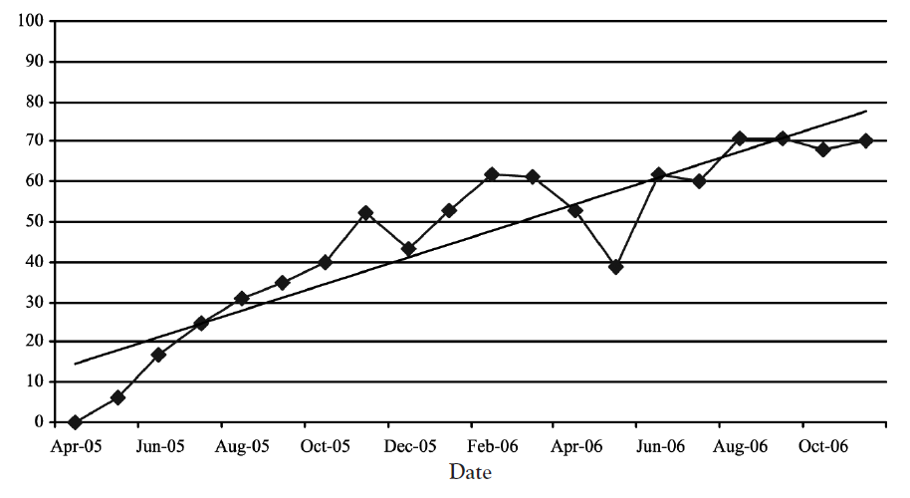
Stand-alone and combination requirements
In 2006, a total of 60,253 Community Orders with only one requirement were issued. In 19 of these the requirement was a MHTR. In contrast 39,392 single-requirement orders for Unpaid Work were issued over the same period. 72 per cent of all MHTRs used with a Community Order were combined with a Supervision requirement.
From the existing data it is not possible to draw any firm conclusions as to why the courts are rarely issuing other requirements alongside the MHTR, such as Unpaid Work, Drug Rehabilitation or Accredited Programme. It seems that offenders with mental health problems are being denied access to the full range of sentencing options by both criminal justice and health practitioners and there could be an association with mental health stigma and discriminatory attitudes. This hypothesis shall be explored in the course of the Sainsbury Centre’s research programme on the MHTR.
Regional variation26
During 2006, seven out of the 42 probation areas – London, Kent, West Midlands, Merseyside, Thames Valley, Essex and Greater Manchester – accounted for 55 per cent of all MHTRs issued despite the fact that these areas accounted for 36 per cent of the total number of requirements issued nationally.
The London probation region used the MHTR more, both numerically and proportionately, than any other region. In 2006 they issued 201 MHTRs, 0.8 per cent of the total numbers of requirements issued in London with Community Orders.
In contrast, London’s usage of MHTRs was proportionately more than four times higher than the lowest issuing region of Yorkshire and Humberside. The latter issued 39 MHTRs, 0.16 per cent of their regional total.
- Further variations are notable in the 2006 figures for the 42 probation areas:-
- 20 issued fewer than 10 MHTRs;
- 8 areas issued MHTRs less than 5 times each;
- Northamptonshire issued a MHTR only twice – out of 4,851 requirements levied;
- North Yorkshire issued a MHTR only twice – out of 2,861 requirements levied.
Ethnic and gender variation
Only 9 per cent of the general population of England and Wales derives from non-white ethnic groups, but 25 per cent of the prison population is comprised of people with a non-‘white British’ ethnicity.14
There was significant variation by ethnicity in the use of the MHTR in 2006. 28 per cent of all MHTRs issued during this period were given to non-white ethnic groups. 12 per cent were issued to black or black British offenders and this group also received the MHTR proportionately more often than any other. These figures must be considered within the context of the regions where the MHTRs were issued, i.e. the London probation region may contain a higher proportion of people of non-‘white British’ ethnicity than areas issuing fewer requirements.
An average of only 14 per cent of all requirements issued with Community Orders were for female offenders, with 15 per cent of MHTRs issued to females. Proportionately women were more likely to be given a drug treatment requirement than men and more likely to receive a supervision requirement, but less likely to receive an accredited programme requirement. Comparatively, women are as likely to receive a MHTR as men.
Obstacles to use of the MHTR
The court may face a number of difficulties in issuing the MHTR and these may explain some of the shortfall in its use. The Sainsbury Centre’s initial assessment of the available data offers some suggestions, not in any order of importance, as to why the MHTR may be less well used than other requirements of the Community Order.
Legislative obstacles
The law states that the offender must have enough of a mental health problem to warrant the requirement, but not so great as would warrant the making of a hospital order or guardianship order under the Mental Health Act 1983. Despite the high prevalence of mental health problems among offenders serving community sentences, the requirement is therefore only suitable in very particular cases.
It is instructive to revisit the actual wording of S. 207 (3) Criminal Justice Act 2003:
“A court may not by virtue of this section include a mental health treatment requirement in a relevant order unless
- the court is satisfied, on the evidence of a registered medical practitioner approved for the purposes of section 12 of the Mental Health Act 1983, that the mental condition of the offender-
- is such as requires and may be susceptible to treatment, but
- is not such as to warrant the making of a hospital order or guardianship order within the meaning of that Act;
- the court is also satisfied that arrangements have been or can be made for the treatment intended to be specified in the order (including arrangements for the reception of the offender where he is to be required to submit to treatment as a resident patient); and
- the offender has expressed his willingness to comply with such a requirement.”
The necessity for consent (which also applies for alcohol treatment requirements and drug rehabilitation requirements) may be a stumbling block for the courts even in the cases where the first two potential obstacles (as set out in (a) and (b) above) have been addressed, because of the stigma attached to disclosure.
Research has shown that mental health service users in the general population have repeatedly identified stigma and discrimination as significant obstacles to their quality of life and access to employment and other services.27 As a consequence, the prevalence of mental illness stigma can be a powerful influence on offenders in open court. The offender may feel that consenting to drug or alcohol treatments is preferable to consenting to mental health treatment, although it is possible that mental health problems could be the underlying issue.
Access to services
There is a lack of access to mental health services for offenders supervised in the community. A report commissioned by the Home Office and the Department of Health published at the end of 2005 looked at community provision for offenders. It concluded:
There is a particular dearth of mental health provision for offenders in the community. Whilst the Offender Mental Health Care Pathway published in January 2005 by the Department of Health provides some examples of good practice, this primarily relates to the provision of mental health services to ex-prisoners discharged into the community.28
Mental health assessment
One of the most substantial obstacles that prevents the court from issuing a MHTR is the apparent difficulty in obtaining access to psychiatric assessment, the gateway to this disposal.29 Assessment by a s. 12 approved doctor is an essential pre-requisite to the process, even where the treatment of the requirement is going to be carried out by a chartered psychologist.
Many offenders who have mental health problems are not given a MHTR simply because their mental health needs have not been identified. Before a MHTR can be imposed, a psychiatric assessment must be carried out. If this assessment is not arranged and conducted, the MHTR will not be issued, thus depriving the offender of the care, treatment and interventions that could make a crucial difference both to their mental health and their offending behaviour.
The problems of obtaining timely psychiatric assessments can be due to local budgeting or time pressures. Yet even where assessment has been arranged, it has been suggested that unless the psychiatric reports are commissioned by psychiatrists with local connections it may not be possible to access local mental health services for the offender.30
Complex needs
Research by the voluntary sector service provider Turning Point demonstrates that offenders on community sentences, who have both mental health and drug problems, face particular difficulties accessing services and treatment. They found that “…support is not offered for mental health needs until after drug treatment has ended or may not be offered in cases in which mental health needs are only identified once treatment has started. Some areas don’t take people with mental illness because these clients are assessed as not being able to cope with the available treatment’.31 In addition, offenders are more likely to receive an alcohol or drug treatment requirement if they have a dual diagnosis, than a MHTR, as part of their community sentence.
Similar problems confront offenders with complex needs. Research amongst Revolving Doors’ clients, many of whom had spent different periods on community sentences and often also in custody, revealed that:-
- just under half required support to address at least two significant problems, such as housing difficulties, drug issues and alcohol dependency;
- offenders with mental health problems on community sentences have been slipping through the net of services with their needs unidentified;
- a third of clients had some unmet needs.
- of the third, a small proportion were at immediate risk of physical or mental ill health.32
The MHTR research project
A key priority for the Sainsbury Centre’s criminal justice programme is to redirect people with mental health problems into care and treatment and, where appropriate, away from custodial sentences. The data presented in this article describe both the rising trend in usage of community sentencing, and the infrequent and differential application of the MHTR. This requirement may offer offenders with mental health problems a viable alternative to custodial sentences. In the absence of a clear understanding of its application and effect, however, it is less likely that a recommendation for MHTR will be made.
To remedy this situation, the Sainsbury Centre has commenced a research programme to address the knowledge deficit in this important area of policy and statute. During 2008 the Centre is collecting primary data to explore the MHTR, its usage, delivery and impact across nine boroughs in Greater London.
The research will explore how an offender is issued with a MHTR, and the decision-making processes prior to, and at the point of, sentencing. There will be a particular focus on identifying the factors that facilitate or prevent a MHTR being issued.
Since there is currently very little known about how an offender is managed and co-ordinated post sentence, the research also aims to acquire an understanding of the detail of MHTR treatments, the key professionals or agencies involved in delivering the MHTR, and relevant processes and procedures for implementing the sentence.
To that end, interviews will be conducted with a range of professionals and practitioners from courts, probation and healthcare services, as well as relevant voluntary sector professionals involved in after-care services following sentencing.
The research will be conducted in three phases: at the court level, in probation and in healthcare. The interviews with sentencers and legal professionals have explored awareness and identification of mental health problems, understanding and awareness of the MHTR and the barriers that are preventing a requirement from being issued.
The forthcoming interviews with staff from probation and healthcare will indubitably draw attention to a range of related issues, which it is hoped will inform the development of a framework for addressing the key research questions.
Conclusion
The mental health of offenders continues to be a pressing issue for policy makers, and health and criminal justice practitioners. Appropriate care and treatment for mental health conditions is not often best delivered within the prison estate. As a consequence there has been an increasing focus on diversion to alternative settings that will address both retribution and rehabilitation for this group.
For example, the Corston review33 recently recommended that:
DH at the highest level should reconfirm its commitment to implement not just its own Women’s Mental Health Strategy but also to the action it signed up to in respect of the Women’s Offending Reduction Programme (WORP). This will require senior leadership within DH.
The government replied as follows:34
Part of the work on the Women Offenders Health Pathway will include consideration of whether the mental health needs of women offenders could be best addressed through making more use of the Mental Health Treatment Requirements as part of a community order, or if a different approach would be more effective.
Similarly, in February 2008 the Justice Minister, Lord Hunt, spoke about tackling offending by improving health. He said:
“With the Court Service we will improve liaison with NHS mental health bodies, so that offenders who are suffering from mental illness can have their conditions fully considered by the courts before sentencing.
The Sainsbury Centre reported recently that not enough use is made of the mental health treatment element of community orders. They concluded that people are currently serving prison sentences who might possibly have been disposed in the community had the courts made fuller use of this sentencing option35.”
However against this background of heightened interest in the use of the MHTR, the actual numbers issued have fallen. Probation quarterly statistics for the quarter July to September 2007 confirm that there were 173 MHTRs attached to Community Orders. These figures represent a 30% decrease in use from the previous quarter.36
The Sainsbury Centre’s research programme into the MHTR will provide the opportunity to explore the workings of an extant piece of under utilised policy and statute. At the end of the project the Centre will be in a stronger position to make informed recommendations. Updated information will be made available as the project progresses, on the Sainsbury Centre website (www.scmh.org.uk).

1 Respectively: Head of Policy; Policy Officer; Research Assistant; Head of Research – all at the Sainsbury Centre for Mental Health.
2 Unless otherwise stated, statistics on the use of community orders were obtained from the Ministry of Justice and are unpublished.
3 http://www.guardian.co.uk/uk/2008/jan/02/conservatives.politics
4 (http://www.guardian.co.uk/society/2008/feb/24/prisonsandprobation)
5 Home Office (2007a) Prison Population Projections 2007 -2014, England and Wales 11/06. London. Home Office
6 Fazel S and Danesh J. (2002) ‘Serious mental disorder in 23,000 prisoners: a systematic review of 62 surveys’, Lancet 359:545-550.
7 Social Exclusion Unit (2002) Reducing re-offending by ex-offenders, London: SEU
8 Singleton N, Meltzer H and Gatward R. (1998) Psychiatric morbidity among prisoners in England and Wales, London: ONS
9 Singleton, N., Bumpstead, R., O’Brien, M., Lee, A. & Meltzer, H. (2000) Psychiatric morbidity among adults living in private households, 2000. London: Office of National Statistics.
10 Home Office (2006), A Five Year Plan for Protecting the Public and Reducing Re-offending, London: Home Office, p. 26.
11 Duncan G. (2008) From the Inside: Experiences of prison mental health care. London. Sainsbury Centre for Mental Health (www.scmh.org.uk)
12 Solomon E and Rutherford M (2007) Community Sentences Digest, London: Centre for Crime and Justice Studies
13 Mair G and May C (1997) Offenders on probation. Home Office Research Study 167. London: Home Office
14 London Probation (2002) The London Probation Area Strategy for Work with Mentally Disordered Offenders. London Probation, p. 1
15 See footnote 8 above.
16 The Community Order should not be confused with the Community Treatment Order (a/k Supervised Community Treatment) enshrined in the Mental Health Act 2007. See ‘Towards an Understanding of Supervised Community Treatment’ by Mt Kinton, earlier within this issue of the JMHL.
17 Home Office (2007b) Sentencing Statistics 2005. London: Home Office. p. 12–13.
18 See footnote 5 above.
19 As prescribed by law however, for offenders whose crimes were committed before April 2005, previous sentence types were applied.
20 National Probation Service (2006) The Tailored 12 Requirements Poster, London: Home Office
21 Mair G et al (2007) The use and impact of the Community Order and the Suspended Sentence Order. London: CCJS, p. 9
22 Clark, T., Kenney-Herbert, J. and Humphreys, M. S. (2002) ‘Community rehabilitation orders with additional requirements of psychiatric treatment’, in Advances in Psychiatric Treatment, vol. 8, pp. 281–290, http://apt.rcpsych.org/cgi/reprint/8/4/281.pdf
23 S 207 Criminal Justice Act 2003
24 Ministry of Justice (2007) Probation Statistics Quarterly Brief, April-June 2007, England and Wales http://www.justice.gov.uk/docs/q2brief-probation-2007.pdf
25 There are no figures for December, owing to fewer sentencing days.
26 See footnote 1 above.
14
27 Thornicroft G, Rose D, Kassam A and Sartorius N (2007) ‘Stigma: Ignorance, prejudice or discrimination?’, British Journal of Psychiatry. 190: 192-193.
28 Offender Health Care Strategies (2005) Improving health services for offenders in the community, (http://www.ohcs.co.uk/pdf/guides/000101_hop_report.pdf
29 A DH project piloting Service Level Agreements for securing timely psychiatric court reports is currently in process in London and the South West.
30 NACRO (2007) Effective mental healthcare for offenders: the need for a fresh approach, London: NACRO, p. 12
31 Turning Point (2004) Contribution on alcohol and drugs to the Big Conversation (http://www.turning-point.co.uk/NR/rdonlyres/A99F485D-EE0B-4029-AB07-39AB5D374D6F/608/TheBigConversation.doc)
32 O’Shea N (2003) Snakes and Ladders: Findings from the Revolving Doors Agency Link Worker Scheme
33 Home Office (2007) A report by Baroness Jean Corston of a review of women with particular vulnerabilities in the criminal justice system. (http://www.homeoffice.gov.uk/documents/corstonreport)
34 Home Office (2007ii), The Government’s Response to the Report by Baroness Corston of a Review of Women with Particular Vulnerabilities in the Criminal Justice System.(http://www.justice.gov.uk/docs/corston-review.pdf)
35 The full speech is at http://www.justice.gov.uk/news/sp080208a.htm
36 Ministry of Justice/National Offender Management Service. Probation Statistics. Quarterly Brief. July to September 2007. England and Wales. Table 4. (http://www.justice.gov.uk/docs/q3brief-probation-2007.pdf)

