Between institutional strategy and disciplinary differences: the speculative redesign of university courses for preferable futures
Susannah Quinsee, Vice-President (Digital and Student Experience), City St. George’s, University of London. s.quinsee@citystgeorges.ac.uk
https://orcid.org/0000-0001-6433-8877
Martin Oliver, Institute of Education, University College London.
https://orcid.org/0000-0003-1836-6257

Abstract
This paper explores the challenges of curriculum design in Higher Education, focusing on the difficulty of balancing disciplinary and institutional priorities.
During the pandemic, the ‘pivot’ to online teaching kept universities open, but created new problems for marginalised students and for teachers. When campuses re-opened, the rush to return to ‘normal’ also reintroduced long-established forms of prejudice and exclusion, locking in economic logics and the commodification of academic work in place of pedagogies of care. Many new practices that were normalised during the pandemic were discarded with the return to campus. Yet the landscape of higher education had changed in that time.
Recognising that both moves were problematic, we undertook a research-led, speculative programme of research. We undertook interviews exploring staff experiences of pandemic pedagogies, analysing these to create tasks for a LEGO® Serious Play® workshop imagining unrestricted possible future delivery models. This workshop identified competing priorities between participants, with disciplinary norms (e.g. for class sizes) taking precedence over institutional priorities (e.g. for efficiencies of scale). These tensions were used to generate design prompts, framing curriculum design in terms of competing priorities that must be balanced within and across course designs.
These prompts then formed the basis of a second workshop, where course teams from a range of disciplines planned the future redesign of their courses with more constraints. Rather than converging on pre-specified models or templates, the workshop provoked participants to speculate on the kinds of future they wanted to create for their courses, and how these might be accommodated within the limited resources and capacities of the institution.
We conclude by reflecting on the successes and challenges of this approach, and the value of the design prompt for use in other institutions.

Keywords
Curriculum design, Speculative design, Ethics in practice, Academic Development, Organisational change

Introduction
The competing priorities that shape curriculum design in higher education create ongoing challenges for academics, and for the staff who support them. This paper explores a process that can be used to work through these competing priorities.
First, research exploring the campus as part of students’ experiences of higher education is reviewed. Then, theories of speculative design are introduced. These issues and approaches were mobilized through a sequence of small studies, as described in the methodology. The findings of each stage are then presented. The paper concludes with a discussion of the issues raised, and the limits of this approach.

The curriculum as a sociomaterial achievement
Scholarship of the curriculum in Higher Education has developed rapidly across the last couple of decades. Historically, ‘the curriculum’ was often conceived of as little more than a reading list, or once quality processes were introduced, an outline of an academic’s intentions for teaching (Fraser & Bosanquet, 2006). An important shift introduced the idea that the curriculum was not just a plan, but also a form of practice – one that required adaptation to specific leaners and their needs, and which balanced disciplinary knowledge with preparation for professional practice (Barnett & Coate, 2004). In the field of educational technology, questions of infrastructure and mediation were raised, leading to a focus on learners and their activities, set within a broader ecology of technologies, teachers and fellow learners (Beetham & Sharpe, 2019). However, this development rarely recognised the spaces and places where learning and teaching happened, until the Covid lockdown closed campuses and took these away (Beetham & MacNeill, 2023).
Research interest in the educational role of campus is relatively recent, and has been under-conceptualised (Temple, 2008). Interest grew under the joint pressures of dwindling finances across the sector and competition from online provision that promised access at a scale that campuses could not match. Advocates for online education condemned universities as ‘closed’ spaces, when contrasted with Massively Open Online Courses (MOOCs) or other forms of ‘open education’ (e.g. Downes, 2011); they went on to talk about the ‘unbundling’ of universities (Weller, 2011; Barber et al: 2013: 5), separating out the services that constituted Higher Education to see which could be outsourced, and consistently suggesting that learning and assessment could take place online.
Forms of distance education have operated successfully for over 150 years in Western Higher Education, and scholars researching students’ experiences have always been aware of the challenges of distributing curriculum resources, supporting embodied forms of pedagogy and providing forms of sociality that can motivate and sustain students’ engagement (Oliver, 2015). The university experience has always spilled out from the campus into other spaces, such as homes, halls of residence, cafes and libraries (Jones & Healing, 2010). “Student experience” as used as a catch-all phrase that covers the intersection of curriculum with that wider university environment. Arguably, until lockdown closed campuses, curriculum theory largely took for granted the way campuses act as a ‘resourceful constraint’, “one it would be premature to write off and which those developing distributed learning need to take seriously” (Cornford and Pollock, 2005: 181). The co-location of students, researchers, libraries, infrastructure and study spaces is not simply about habit or convenience, but actively contributes to successful university study, as recognised by sociomaterial analyses.
Humans […] do not float, distinct, in container-like contexts of education [...] that can be conceptualised and dismissed as simply a wash of material stuff and spaces. The things that assemble these contexts, and incidentally the actions and bodies including human ones that are part of these assemblages, are continuously acting upon each other to bring forth and distribute, as well as to obscure and deny, knowledge. (Fenwick, Edwards, and Sawchuk, 2011: vii)
University campuses are not just (costly) ‘context’ that can be dismissed, but achievements: something created through the repetition and accumulation of practices of research and study over time, which in turn enable such practices to be sustained in the future (Edwards et al, 2011). This layering of materials and practices creates the complex, political meshworks that constitute university life (Sørensen & Traweek, 2022). Indeed the symbolism of certain campus artefacts - the library, the Students’ Union and so on - creates strong identifications for students and staff (Ross & Sheail, 2017).
The nuance of these analyses is often lost, for example in rankings of courses that use the number of hours spent in-person, on-campus in lectures as a proxy for the quality of courses (Barefoot et al, 2016). Bayne et al (2014) describe the ways in which the material practices of teaching, the ‘othering’ of distributed learning and the trope of campus photographs in promotional materials all lead students to treat the campus as “a guarantor of the authenticity of academic experience”, inadvertently contributing to “fetishizing the campus and the enclosed, bricks and mortar spaces of the university”. Even for distance education students, the ‘campus imaginary’ is a powerful influence on their experience and satisfaction; students continue to assume that if only they could actually be physically present at the campus, they would somehow become more real, and become a higher priority for support from their tutors (Ross & Sheail, 2017).
When the Covid-19 pandemic shut campuses around the world, these assumptions – lacking the nuance of sociomaterial analyses – created widespread concern that distributed study simply could not be as good as conventional education. Few teachers were familiar with research evidence about distance pedagogies, and many were physically and emotionally exhausted by the constant competing demands of work and family (Littlejohn et al, 2021). Institutional responses, driven by financial fears, rushed to convert lectures, tutorials and laboratory classes to screen-based environments, ignoring decades of research:
The thousands of refereed articles and scholarly monographs probing the flawed history of online learning were ignored. Instead, academic journalism restated the obvious. […] With the onset of COVID-19, universities in crisis only had one option: panic learning. With the loss of international students – and the revenue that they bring – the change to online environments had to be introduced at speed, throughout all disciplines and with no funding to enable the expeditious implementation. (Brabazon, Quinton & Hunter, 2020).
Studies showed continuities as well as ruptures, however: ‘the lecture’ remained a defining feature of what it meant to students to be ‘at’ university, even if this was now a very different experience during the lockdown.
The notion of the lecture persists and continues to be understood as a central pedagogical feature of university life. Even a pandemic and the complete closure of the campus could not topple the lecture: while lecturers’ homes became their lecture theatres, and recorded lectures streamed at different times to the devices of students around the world replaced in-person gatherings, the difference sticks to the similarity, and they remain relationally bound (Lamb & Ross, 2022).
Meanwhile, the pandemic also preserved – or intensified – inequalities between students. Removing access to campus resources affected those whose homes were not suitable for studying, including those with large families, shared technologies and unreliable infrastructure, and forcing those with the fewest resources to make the greatest sacrifices (Czerniewicz et al, 2020). What had previously been established as ‘normal’ educational practice had never been a universal good, ‘misfitting’ many non-normative faculty and students, including not only those with impairments, but also in relation to race, class, gender and sexuality (Boys, 2021). Reverting back to these practices post pandemic has potentially reinforced these inequities, given the rising student numbers, students whose relationship with education had changed due to interrupted study in the pandemic, and increases in demand for mental health support. Boys concluded that “rather than just waiting for a time when higher education can ‘go back to normal’, [...] the breaching effects of the pandemic are already generating new and innovative ways to collectively discuss and re-think everyday beliefs about how we learn and what we value.” Given the changing needs of students, this is even more vital now.
Taking Boys’ challenge seriously, the research described here sought to resist the rush back to assumptions about ‘normal’ educational practices, asking instead what better kind of future could be created, if the materiality and politics of curriculum design were done differently.

Speculative approaches to designing educational futures
Speculative research poses the question, “is another future possible?”, as a way of opening up possibilities for action in the present (Savransky, Wilkie & Rosengarten, 2017). This is an explicitly critical agenda, actively setting itself against the dominant calculative logics of late modernity that have framed the future in terms of risks to be governed and commoditized.
The idea of speculative methods has gained increasing traction within educational technology. For example, Jewitt et al (2023) used speculative design methods to influence design practices relating to remote touch, developing multimodal fragments grounded in ethnographic data and using these alongside reflective prompts as the basis for a design workshop. This approach provoked and initiated critical interdisciplinary conversations, shaping HCI designers’ practices.
Ross (2023) has laid out a different agenda, focusing on how ideas about educational futures are produced, and how they come to be accepted. She proposes that ‘a speculative research design for education futures research will most likely need: a futures question, an “object-to-think-with”, an audience to engage with and a way to capture responses and other materials generated through the research’ (Ross, 2023: 169-170), with those ‘objects’ including fictions, prototypes and ‘speculative objects’ are identified as things that could be used to prompt people. Arguably, however, Ross’ focus is primarily on discourse, using Jasanoff’s idea (2016) of the sociotechnical imaginary as a point of departure. Jasanoff’s imaginaries involve publicly performed visions of desirable futures that are shared and institutionally stabilized, and which relate forms of social life to advances in science and technology. This focus on discourse connects this work more directly to utopian and dystopian rhetorics, such as those found in policies, and the ways in which such discourses lead people to anticipate and then work towards the futures they present.
One issue that Ross notes with such approaches, however, is that of ‘discursive closures’ (Markham, 2021: 385): “although the capacity for imagining something new or different resides in all of us, the available material for any imaginative act is greatly influenced by prior imaginations”, resulting in the reproduction of dominant, naturalized discourses, and contributing to a sense of inevitability and powerlessness. Markham suggests that if the purpose of speculative interventions is to help people to think otherwise, it may be necessary to refine the process iteratively in order to explore with specific audiences what is felt as critical and urgently needed by particular audiences, for example by introducing historical counterfactuals or examples built around contrasting values. Drawing on Whitehead, Rosengarten (2017: 79) similarly argues that if speculation is to avoid being foolishness, it “requires discipline, systematic modes of undertaking”.
One approach to disciplined and systematic forms of speculation has been developed to analyse ‘techno-moral change’. Noting how classical ethics either ignored technology or treated it as a dominating and alienating power to be resisted, Keulartz et al (2004) turn instead to technology studies to explore the ethics of the processes and practices through which technologies are shaped, illustrating this in relation to the histories of contraceptive pills, biotechnology and cloning. Drawing on Dewey, they call for ‘“dramatic rehearsal,” the imagining of a plurality of possible futures and the ways that lead to their realization. This involves thick descriptions of complex scenarios, of various competing possible lines of action and courses of conduct’ (Keulartz et al, 2004: 20). Brey (2018) goes further, noting that technologies do not simply require consideration of values when designed, but also when they are used and become embedded in society, including the ways in which they stimulate new social and institutional arrangements, and in which they enable forms of action for some groups in society but not for others. Similarly to Ross (2023), Swierstra (2015: 14) advocates that “the anticipation of soft impacts typically takes the form of vignettes offering snapshots of possible future practices, or scenarios describing how current practices are destabilized under the influence of technologies, and how they may evolve in response to these technological challenges”, with the caveat that “they are, and should, be supported by empirical evidence, such as what is technologically feasible, what society wants, how technologies and practices interact, human psychology, and so forth […] So, stories can be, and are, critically tested for their plausibility.”
Swierstra et al. (2009) propose that “to avoid empty speculation, our moral imagining of the techno-moral future has to be grounded in the present. We therefore start by assuming that in future controversies the same argumentative patterns can be discerned that mark previous and current discussions”. These argumentative patterns – existing discourses and practices – can be used to stimulate the creation of stories or vignettes.
However, this suggestion of action is not an integral part of these story-based approaches. As Marres et al (2018) explain, they are representations of rather than interventions in social life. They propose the phrase ‘inventing the social’, arguing “that invention […] involves an active search for alternative ways of combining representation of, and intervention in, social life” (ibid: 18). Drawing on artistic as well as social approaches, and explicitly moving away from the idea that social science should able to ‘engineer’ social phenomena, they draw attention to the reflexive point that social research itself generates new forms of sociality; it does not just create new representations of society. If social research is always already some kind of intervention in society, then ethically and methodologically, it becomes important to explore what types of connection between representation and intervention are made, enabled, and explored in social research. Studying social processes always involves inviting, persuading or provoking actors and situations to generate accounts, expressions and articulations of social reality; and moreover, such provocations are inevitably already happening (such as the policies around returning to campus outlined above, as a way of provoking different forms of sociality). “In this context, the question for social researchers and knowledge practitioners more generally becomes: what can we add to experiments already underway?” (Marres et al, 2018: 28). Such ‘what if?’ interventions may include texts, such as stories, but can also include the introduction of new material or digital resources, followed by the question, “how does their participation in social life make a difference to our forms of life; can they inspire alternative forms of knowing and doing?”

Methodology
The research progressed through a series of phases, each of which will be outlined in turn.

Exploratory interviews
The first stage involved interviews with one lecturer and one member of support staff, focused on their experiences during lockdown. The interviews followed the approach developed in a previous project (Littlejohn et al, 2021), opening with discussion of a routine day during lockdown, then discussing the points raised during this opening narrative in greater depth. Interviews were conducted on Teams, were recorded and transcribed, and were analysed using reflexive thematic analysis (Braun & Clarke, 2021).

LEGO® Serious Play® workshops
The LEGO® Serious Play® method was chosen for the first workshop, post the interviews, because it is a free-thinking and engaging technique that fits with the speculative approach outlined above. LEGO® Serious Play® “is a thinking, communication and problem-solving approach for topics that are real for the participants” (Kristiansen & Rasmussen, 2014, p. 43). It is based on four core principles around building, sharing, reflection and truth. The method enables storytelling to uncover greater meaning (Roos, Victor, Statler, 2004). Participants are asked to build models relating to a set of questions which started with the pandemic and moved on to imagine possible futures. To ensure familiarity with LEGO® an initial skills building activity precedes the thematic questions. This is critical part of the methodology and vital to ensuring inclusive practice. Participants interpret the questions as they wish, building and then telling the story of their model. Other participants can ask questions and explore their story. As the participants build the models, each question requires deeper exploration and there is frequently a palatable shift in attention as participants exhibit characteristics of flow (Csikszentmihalyi, 2009; Zenk, Primus and Sonnenburg, 2022). After building individual modules, the “red brick” technique was used. This is where participants were asked to identify the core of their module, with a red brick, and extract that from the rest. Then these cores were brought together to create a shared model that told the story of all the participants responses to the question. The stories participants told about their own model, and the discussion of the final shared model, were recorded, transcribed and analysed using reflexive thematic analysis.

Development of speculative provocations
After the workshop, the themes produced from the analysis were documented and used to run a speculative provocation session with institutional leaders responsible for leading on strategy around place, space and pedagogy. The representation of the themes was intended to generate a bridge between the unrestricted possible futures emanating from the LEGO® Serious Play® workshop and the reality of delivery in a constrained university environment. Rather than record and analyse the conversation, the focus for this step was on refinement of the provocations, ensuring these were grounded both in the anticipated needs of the institution, as well as the historic lived experiences of staff members.

Engaging and Effective Delivery Workshop
From the above activities, a set of materials was produced that incorporated the revised representation of themes. These materials were used to scaffold a speculative workshop exploring engaging and effective delivery for the future. The themes from the interviews and workshops were used to create a grid that participants could use to describe the choices made about current forms of module delivery. Participants were asked to map their modules onto the grid using LEGO® bricks to explore the impact of their choices on student experience, staff experience, estate demands and resource requirements. Once this mapping had been completed, participants were then asked to explore the impact of a set of provocations on delivery relating to participation (blend and flex), resources (cohort size and staff resources) and facilities (place and platform). This enabled a discussion about what support was required for change, and the impact of different possible futures on delivery.

Research ethics
Ethical consent was gained from both universities. All participants were provided with information sheets outlining the project, were given the opportunity to ask questions, and signed an informed consent sheet before taking part in any of the stages of the research. Anonymity and confidentiality were assured, and participants were reminded of their right to withdraw from the study at any time.

Findings

Interviews exploring staff experiences
The two participants had different roles, one teaching on a postgraduate programme and the other providing support and training for teaching staff as they moved courses online. Both taught online during the pandemic, and were able to discuss colleagues’ experiences as well as their own.
Learning to teach online demanded familiarity with a range of technologies, which were often unfamiliar, including recorded lectures, forum posts, quizzes, polls and student tracking. This caused anxiety and a loss of professional confidence.
Academics were feeling very stressed, of course, incredibly stressed. You know, some of them were really, really hating it intensely.
Opportunities to share practice with colleagues helped, however.
Turns out that there were some academics who have been delivering a sort of hybrid model for years, only we didn't know that was going on. [...] It was a lot of sharing, which was, I think, a positive.
Experiences varied depending on student needs. Many professional students had good home networks and managed their online learning effectively; some students struggled; and many were just unknowable, which caused great concern.
A lot of them were saying, [...] it's a lonely place to teach. It's very lonely. You talk and [it’s] empty, no one turns the camera on. [...] And they just felt very lonely.
Peoples’ home environments varied considerably. Internet access could be unreliable, and lack of physical movement was also a concern, with people sedentary in front of small screens for long periods. Many staff invested personal money to create spaces for work, creating a greater sense of control and comfort than they experienced on campus.
Now at least I have at home a two-screen setup with a camera and everything, so, you know, I would have felt more comfortable.
Mirroring in-person timetables created issues for everyone – people were exhausted and lost concentration in synchronous half-day sessions.
We were all very Zoomed out at that point.
A particular issue was the lack of socialisation – this was particularly difficult for early career staff who did not have well-established networks.
Even like in the small amounts of breaks we had [...], at that moment you'll be completely alone. You wouldn't have any kind of social interaction with anyone else. You wouldn't have any casual chat in between, you got your coffee on your own and then came back to the lecture.
The flexibility of online work compounded this, as some people chose not to move to London, saving them money but preventing future socialisation. Having the choice not to come to campus made events such as seminars open to wider audiences, and eased childcare responsibilities, but also made events feel impersonal and isolating. Some students believed the loss of a London venue diminished their experience.
One of the attractive aspects [...] is that you are in London. [...] So I think taking that away takes away a lot of the allure, the prestige.
These themes – loss of professional confidence, varied student needs, home and office infrastructure, wellbeing, socialisation, flexibility and isolation – were then used to design the prompts and questions for the next phase of research, the LEGO® Serious Play® workshop.

LEGO® Serious Play® workshop
The LEGO® Serious Play® workshop involved 5 participants from a range of discipline areas across the university and lasted 3 hours. After an initial skills building activity to get participants used to the methodology and using LEGO® to make meanings, participants were asked to build individual models relating to questions about educational delivery and student engagement.
The first build responded to the prompt, “build a model of your learning and teaching delivery during the pandemic”. Models built by participants described teaching online as including resources on the VLE, live teaching, watching lecture recordings, email exchanges, forum posts on the VLE, and interactive elements such as polls.
Models addressed both positive and negative aspects of delivery and engagement. Positive aspects included control over their home infrastructure, something not always mirrored on campus; and proactive engagement with support services for students, particularly using Teams teaching communities. Participants also commented positively on community sharing of resources and techniques, which increased during lockdown. However, not everyone had access to a reliable infrastructure at home.

Figure 1: My Internet is on fire
My computer, my Internet is on fire because I'm sharing the house with several other people who are also working online.
There was greater expression of negative aspects, particularly around isolation and disconnection.
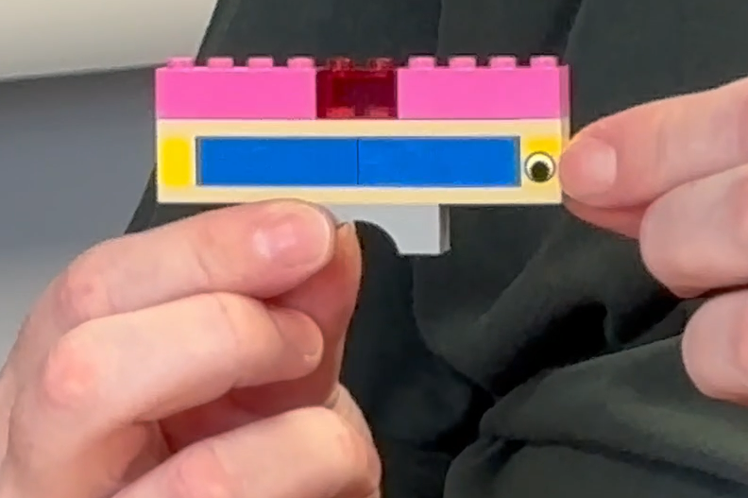
Figure 2: lonely teaching
These are my distributed students. Here is the gulf between us. And then this is my video wall of them. Nobody with a camera on. All little two-letter initials. This one, that's probably my colleague - the only person with a camera on, so at least I don't feel totally alone. (Figure 1)
This manifested through lack of socialisation, the abrupt end to online meetings (as opposed to a more organic conclusion and movement from a shared space when on campus); lack of serendipitous interactions; online community building events feeling over-engineered; and difficulties asking questions. This had a particular impact on early career and PhD students who were not able to build connections. Enrichment activities such as fieldwork and teamwork often stopped when programmes were delivered online. There were reflections on the importance of place; as signifier of prestige (being a central London university, on campus activities have status due to opportunities to network), as offering serendipitous interactions; and as evoking calmness (e.g. the symbolism of the library as a space of reflection and quiet study which was missing during lockdown).
The models expressed a range of emotions relating to teaching online during the pandemic, particularly the stress and exhaustion of teaching for long periods of time online, the need to prioritise personal wellbeing in new ways, coupled with a sense of freedom as everything was taking place within the home environment.
So this is the fear, when you're chucked into the deep black sea of online learning, is that the whole world is observing you as a teacher and condemning you for not being good enough. [...] Not only is it in the classroom, but you've potentially got the whole virtual world looking at you. You're being recorded. You've got hundreds of students. So it's about judgement and sense of fear with that.
Participants commented that there was a greater sense of informality as people were less concerned about how to present themselves. At times this led to increased support for colleagues to ensure that everyone was able to cope with teaching in new ways. Other positive aspects related to the flexibility of being able to combine caring responsibilities with work and reduced costs due to less travel expenses. However, disconnection from students who kept their cameras off, and not being able to read the body language of students, exacerbated feelings of isolation.
I like people in the room. I like to watch their body language. And if a student is like, just, looking away from me, I can kind of go, “are you OK?” I couldn't do any of that. So all I could occasionally glimpse were students when they did have their cameras on, some of whom were asleep.
Participants then adapted their models to demonstrate how their learning and teaching delivery had changed since the pandemic. (At this point, in October 2024, the majority of teaching was back to in person delivery.) Participants were engaged in both fully in-person teaching on campus and hybrid teaching, where students were either in the room or joined remotely. In-person teaching involved presentations to groups, student discussions and collaboration, teaching staff actively moving around teaching locations, ensuring time was productively spent this was particularly important for international students, and involving opportunities for serendipitous interactions. There was also the recognition of the role of supporting services, particularly the library and access to materials that were not available online.
Hybrid teaching was challenging.
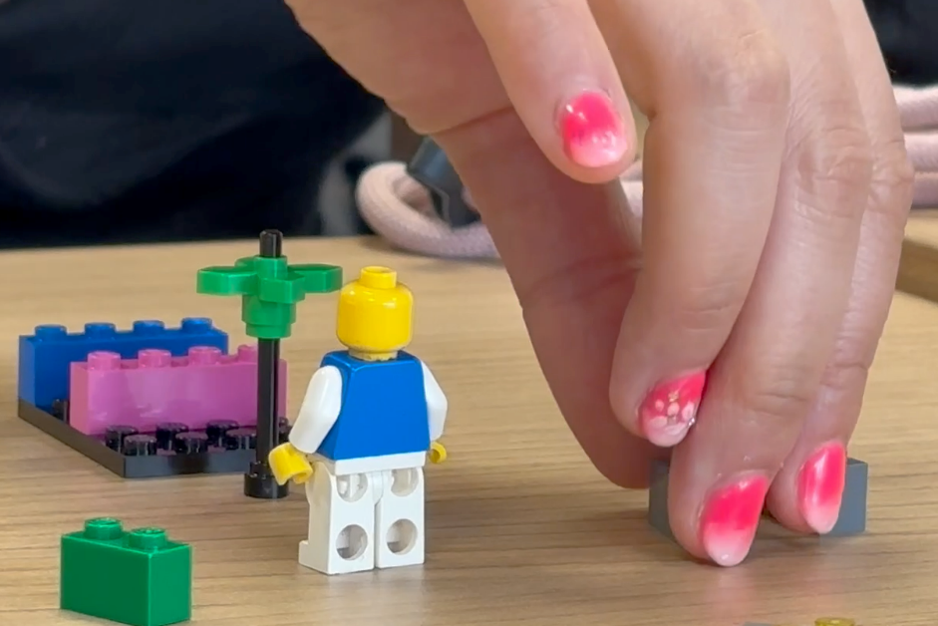
Figure 3: Trying to bridge the gap
Every single lecture was kind of me just trying to bridge the gap between people in the room [...] and trying to link the people that were just on the camera, on Zoom, and yeah generally it would end up like not really working. (Figure 2)
Issues included balancing flexible participation with activities that engender participation. There were challenges about ensuring enough students were present in both modes, and problems presented when students suddenly changed modes, which impacted planned activities. Observations were made about shifts of power when students could choose how to interact with planned sessions, although some participants commented that, due to lecture capture, some students had been already taking this optional approach for a while pre-pandemic.
The adapted models expressed some frustration with the constraints of on-campus teaching environments and the lack of flexibility, particularly for large-scale teaching.
Lastly, participants were asked to build a model of what teaching delivery would look like in ten years’ time. The “red brick” technique was used, with participants asked to identify the most important part of their model, denoting it with a red brick and then collectively combining all their “red brick” elements to create a shared model of what future teaching would look like.
Creating the shared model proved challenging for participants. A particular issue was the impact of different disciplines on the creation of the shared model.
It's the concept that they implement the ability for the person creating content to create it in a way and deliver it in a way that is appropriate to that subject, and for everybody else to be able to view it and engage in it in a way that is fully accessible to them and appropriate to them.
Participants are expected to negotiate and create a shared story of the model that identifies and unites their individual components into a collective model. Participants struggled to build a coherent narrative of what teaching delivery would look like that combined the individual elements. This was surprising given the consistency of themes identified in the individual builds.

Development of workshop materials
The difficulty of producing a single shared account was treated as an important finding. Rather than forcing resolution, or trying to develop a single template to apply across all courses, the issues raised in the previous workshop put into relationship as design choices (Table 1).
On the one hand... |  | On the other...
Flexibility about where and when to study | Flexibility | No sense of community due to fragmentation
Individual choices about where to study | Distribution | Loss of campus facilities and the location as ‘brand’
Personalisation of the curriculum, with student-centred support | Adaptation | Surveillance of students to monitor progress, ‘teachers on demand’ 24/7
Bespoke, tailored courses | Curriculum | Loss of curriculum coherence, decontextualized knowledge
Teaching as a special event | Event | Everything is recorded and distributed as a resource
Giving learners a clear and well-structured experience | Structure | ‘Spoon feeding’ and fostering dependence
Scaling up by standardization, making it affordable | Scale | ‘One size fits all’ that might not satisfy anyone
Table 1: Design choices
The design choices and a proposed workshop outline were taken to a management group with responsibility for curriculum development. This consultative process provided an opportunity to test the analysis against institutional needs.
While the issues were recognised as relevant, expressing this in terms of choices felt out of line with the institutional need to support and manage courses. In contrast to the open design space suggested by Table 1, the institutional preference was for templated courses and relevance to strategic concerns.
These contrasting expectations from teachers and managers were brought together by using a simplified map based on the design choices, together with a series of provocative questions linked to institutional needs. The simplified map clustered the choices into four quadrants (Figure 4).
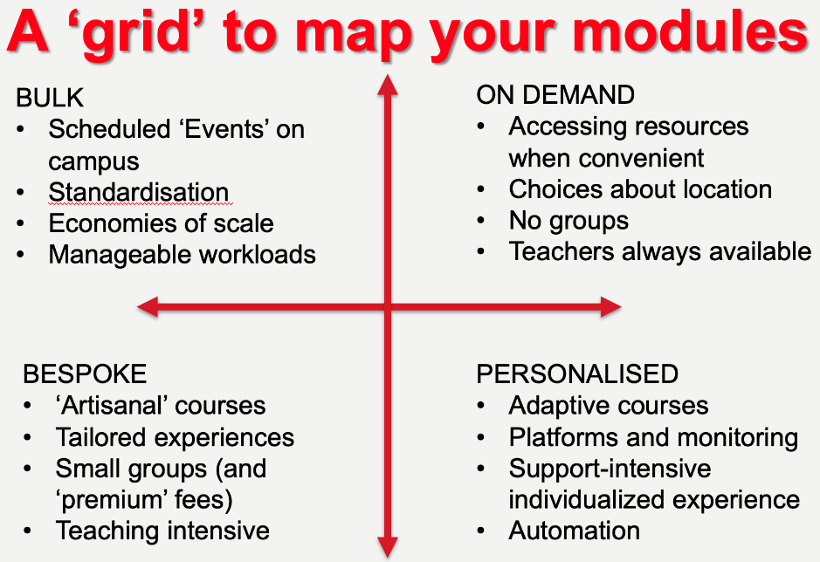
Figure 4: The mapping of design choices
While the mapping grid offered a restrained range of choices, these were expressed as ranges or qualities rather than binary choices – for example, a course might be described as more personalised and less bespoke, rather than simply falling within one of four ‘types’. Further, a course might consist of components (e.g. modules), each of which could have different qualities.
Complementing this were the speculative provocations, intended to test course designs against possible futures (Table 2).
What if we mandated all programmes to be delivered 20% online?
What if visa changes stopped international students from coming to the UK?
What if we stipulated group sizes? (40 for seminars, 120 for lectures)
What if you can’t have the rooms you want for that scale of teaching?
What if attendance at classes was made optional?
What if employers wanted all graduates to be fluent users of generative AI?
What if courses could only use a pedagogy that was explicit about how it advanced our strategic mission?
What if the fee levels for home students were cut by 50%?
What if the fee levels for home students were raised to meet international student fees?
Table 2: Speculative provocations
While the consultation with managers pushed the design process away from free speculation and towards risk management, the workshop was developed to invite the exploration of choices within constraints. This addressed Swierstra et al’s (2009) admonishment to avoid empty speculation through empirical grounding, and – following Marres et al (2018) – used the experiences of staff from earlier phases of the research to add something to the ‘experiment’ of curriculum redesign that was already underway in the institution.

Engaging & Effective Delivery Workshop
Attendees were grouped together by programme. Groups were asked to map their biggest modules against the grid. Then they were asked to create a LEGO® tower to visually represent the student experience, staff experience, demand on estate, and demand on resourcing, using red, yellow, and green blocks (Figure 5, Figure 6).
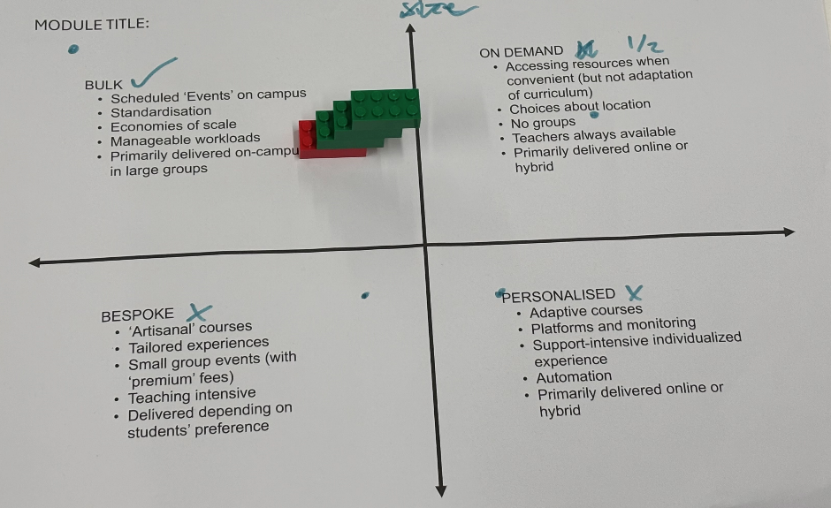
Figure 5: A mostly unproblematic 'bulk' module
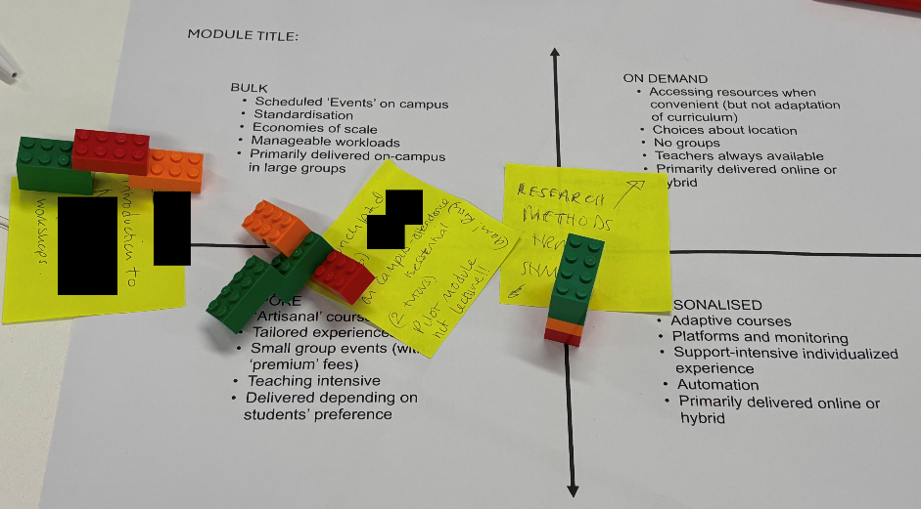
Figure 6: An anonymised mapping of three modules, with challenging or problematic elements.
Attendees were asked to consider the following:
- What delivery models are currently being used in their module?
- What evidence do you have to support your chosen approaches?
Social Sciences
Modules delivered in the Social Sciences were characterised as “bulk” delivery, reflecting large student cohorts (with the largest capped at 600+) and a high reliance on on-demand provision such as lecture capture, pre-recorded lecture content, and Moodle discussion boards. However, a few modules included bespoke elements that were highly interactive. These typically required greater resources and estate usage, particularly where laboratory or workshop components were central to learning.
This emphasis on large-scale delivery created efficiencies and kept costs relatively low, though it limited opportunities for deeper personalisation of the student experience, and required high estate usage to support the large cohorts.
Science and Technology
Modules for year 1 students were often similar to the “bulky” modules in Social Sciences, but those for year 2 and 3 students were often bespoke or on-demand with some personalisation. These resource-intensive modules often involved labs or projects. This encouraged a high degree of student self-organisation but also placed considerable demands on teaching staff to coordinate and monitor progress. They typically required assigning dedicated staff to groups, ensuring students received consistent guidance and support throughout the project lifecycle.
Some modules in Engineering were taught 40-50% through online materials accompanied by groupwork and tutorials. Staff described reduced attendance at tutorials, especially where sessions were taught on different days. Student engagement improved when tutorials required active participation to progress, highlighting the importance of structured tasks in maintaining interaction.
While effective for skill development and collaboration, these approaches involved higher costs and were resource intensive (although some of these demands were offset by government subsidies).
Law
Large cohorts studying Law were managed through repeat sessions, including an online option. This offers flexibility but also generates high resource costs. The student experience can be uneven, with some lectures accommodating 500 students and others 150, creating varied engagement levels. Large group teaching can create distractions for students, and in-class disruptions have had a negative impact. A student charter was introduced to manage behaviour and expectations of participants when disruptive activities occur.
Tutorials combine reading and interactive activities, alongside learning experiences that increase student engagement. In response to student absence caused by lack of preparation time before tutorials, scheduled ‘prep time’ was introduced. This has been effective in addressing the problem.
While the model provides a high institutional contribution with relatively low cost per student, it also intensifies staff workload and highlights tensions between scale, quality of engagement, and feedback provision.
Health and creativity
Modules emphasise practical, bespoke skills directly relevant to workplace contexts. Delivery often includes large introductory cohorts (e.g., 100 students) followed by smaller workshop groups with multiple tutors. Estate constraints present challenges for attendance and student experience, highlighting the tension between timetabling and accessibility.
Research-based modules bring together students from different programmes, supporting widening participation and enabling flexible, hybrid learning. While this model increases interaction and inclusivity, it carries risks from technology failure and staff discomfort with online delivery, as well as high resource requirements.
These approaches are strong in applied, student-focused learning but rely heavily on resources and careful planning to maintain engagement and equity.
From current delivery to speculative scenarios
After mapping current practices and identifying their profiles in terms of student experience, staff experience, demand on estate, and demand on resourcing, the workshop explored how changing contexts could shape delivery choices and potential outcomes. Using scenario-based questions, attendees were asked to consider a range of “what if...?” questions, exploring the impact of specific parameters on their current module delivery models. There was then a discussion of the responses across all disciplines. The scenarios explored changes in terms of:
- Participation – blend and flex
- Resources – cohort size and staff resources
- Facilities – place and platform
Here, we will provide illustrations of how these speculative scenarios provoked new design thinking for the programme teams.
PARTICIPATION scenario (Blend): What if the institution mandated that all programmes must be delivered 20% online?
The School of Social Sciences described how it had already explored this scenario in its current practice. Programme design has moved towards blended formats (e.g., 1+1+1 model: 1hr lecture, 1hr recording, 1hr tutorial), increasing access to on-demand resources. This benefits students who struggle to attend on campus due to cost of living or commuting, improving flexibility, personalisation, and reducing bulk delivery. However, participants reported that for interactive and practice-based modules, staff highlighted the importance of knowing students directly, and a mandated blend would diminish the staff–student experience.
PARTICIPATION scenario (Flex): Which delivery choices would impact most positively on the student experience?
The School of Science and Technology discussed how increasing flexibility would need to be planned across programmes rather than only at module level, to manage the risk that students will would experience fragmented schedules (e.g. in-person and online activities on the same day), undermining attendance and satisfaction.
RESOURCES scenario (cohort): What if the institution stipulated that students should not be taught in groups of more than 120 students?
The school of Law felt that this would compromise design, leaving courses caught between bulk and personalisation. 120 would be too few for large lectures but too many for small-group sessions.
Staff would prefer removing lectures in favour of 30-person workshops, supporting deeper engagement with students. However, this would require repeating sessions, reducing staff satisfaction and risking inconsistent delivery, which negatively affects students.
The discussion suggested that a cap on cohort size could be useful but should be department or mode specific. For example, for lectures, they suggested a cap of 200 students may be more appropriate.
RESOURCES scenario (Staff): What if staff–student ratio was set at 1 staff member to 40 students for all teaching purposes?
The School of Science and Technology discussed how some Schools already use indicative ratios, but argued that this should be determined at a departmental level to balance consistency with context. They also added that a strict 1:40 ratio risks over-reliance on Graduate Teaching Assistants, which may not be feasible or equitable.
FACILITIES scenario (Place): What if all lecture rooms were converted to flexible spaces for 120 students?
The school of Creativity and Health discussed how flexible spaces would allow more creative group-based activities, being less limiting to pedagogy than fixed forward-facing seating. However, questions were raised about efficiency and suitability for cohorts that are much smaller. Concerns included timetabling to enable simultaneous modules, flexible computer rooms, flexible transition between sessions of lectures and seminars, and ensuring that any design supports both large- and small-group teaching.
FACILITIES scenario (Place): What if a module could only be taught in blocks of 3 hours?
The school of Creativity and Health suggested that longer scheduled blocks could allow the integration of lecture and seminar activities, encouraging deeper learning and student motivation. However, risks include rigid use of time, reduced inclusivity for students with lower attention spans, and pressure on timetabling (e.g., students potentially facing 6-hour days). Consequently, while this might suit some students, many would find it hard for them to have breathing space during these long sessions. It also concentrated risks: students would miss a high proportion of the course if they could not attend on a single day. A counter-proposal suggested by the Law School was that 1.5-hour time blocks would be optimal.
FACILITIES scenario (Platform): What if lectures are only delivered online, and all seminars were hybrid?
Collective discussion identified external constraints preventing this. While some programmes already deliver 20% online, Home Office restrictions on visas complicate provision for international students. Even where permitted, differential access to technology risks creating inconsistent student experiences across cohorts.
Hybrid seminars were considered viable if coordinated at programme level, but standardisation would be essential. Without planning, high levels of estate use would mean that timetabling becomes unmanageable. Collective adoption would be required to ensure efficiency and fairness.

Discussion
The programme of research outlined in this paper responded to initial unease about the rush to ‘normal’ teaching after the pandemic, mobilising staff experiences to create research-based workshop materials that generated thoughtful and strategic programme designs. This process took time: it involved more than amplifying or broadcasting lived experiences (as with the inputs to the LEGO® Serious Play® workshop), instead demanding that these be staged in ways that specific audiences (managers and other teachers) recognised and could respond to productively. Initial representations of the themes failed to do this, but expressing these as options that helped structure a productive space of legitimate programme designs. This provided new ways of talking about design choices, provoking reflection and supporting comparisons with other teams’ practices. Our work as researchers was not to identify the ‘right’ option for teams, but to provide concepts and resources they could use to express what was ‘right’ for them (keeping in mind the challenges and priorities of the institution). Unlike approaches to learning design that work towards standardisation, seeking to validate and transfer templated courses (cf. Laurillard, 2013), or even create machine-readable pedagogies (e.g. Koper, 2006), this work sought to use differences to develop peoples’ capacity to make discerning choices about their design work – to make designing more interesting (Latour, 2004).
Given this agenda, there was no expectation that the whole institution would converge on a shared approach that could be used as a template. Instead, the workshop highlighted that delivery choices inevitably involve trade-offs, which reflected the values and priorities of the different programme teams. It is appealing to think of these differences in terms of signature pedagogies (Shulman, 2005), although realistically, epistemic and moral differences are increasingly tempered by common managerial requirements and social conditions such as fee income (Becher & Trowler, 2001). It was striking that disciplinary differences were more marked in the early discussions, but the use of prompts that confronted teams’ designs with institutional concerns resulted in greater convergence.
Nevertheless, shared learning across schools provided valuable insights. There was collective agreement about the importance of aligning institutional and school visions, flexibility, and inclusivity in shaping the student experience. Practices were shared across departments and common concerns regarding costs, resources and effectiveness on students of each choice were discussed. In particular, the problems of high estate usage demand and staff-resource were emphasised and would need further escalation. Participants committed to concrete actions at programme and school level, building towards institution-wide alignment and a sustainable delivery strategy.
The discussion of students’ differing needs and experiences – whether they involved neurodiversity, equitable access to technology or other considerations – highlighted the need to conduct research and collect data that differentiated students’ wants from their needs, to generate well-designed course and enhance the flexibility of personal choices. Other areas requiring further exploration included developing a wider repertoire of teaching formats and online assessments involving AI applications.

Conclusions
The research described here arose from recognition that both the transition to lockdown during the pandemic and the transition back to campus-based teaching shaped but also hid challenges to established pedagogic models. Our concern was that institutional responses might regulate practice without creating sufficient opportunities for the iterative conversations that good, inclusive programme design needs.
Central to this paper is the idea that the research-based process of reflecting teachers’ experiences back to them in new ways is productive and prompts reflection. While other researchers or institutions might find the design grids, LEGO® workshops or speculative provocations useful, our argument is that this process has value. That process should, at the least, involve the adaptation of the themes, representations and provocations described here so that they engage with local experiences and priorities. We are not seeking to universalise the institutional designs described here; instead, we are seeking to make the design process more interesting (Latour, 2004) by showing how careful attention to differences between programme teams (and managers) can generate thoughtful, discerning pedagogic designs.
Speculative methods proved to be a productive way of creating interest. However, the kind of speculation that was productive in this study did not involve participants free-associating or writing fiction; instead, it involved careful grounding in evidence, repeated testing of provocations to ensure they were comprehensible and generative for their audience (programme teams), and the deliberate creation of contrasts that invited reflection on possible differences. They involved the production of possible near futures from which participants could choose what was preferable and design towards it, rather than the generation of distant utopias (Law & Mol, 2002).
Many differences were generated by disciplinary norms, but we are cautious about claiming these represent stable signature pedagogies or epistemic commitments; they could simply be idiosyncratic. Some – but not all – of these differences gave way when confronted with institutional priorities, such as space constraints. There was, for example, more willingness to change group size for lectures than there was to give up embodied forms of practices such as arts performances or practical laboratories. These points of resistance may be helpful in find a balance between what is dictated by university policies, and what can be decided at programme and module level.
The focus on teachers’ experiences here obviously tells only part of the story of education. Teachers regularly provided stories of students’ lived experiences, and the final workshop highlighted the need to research students’ expectations and needs. Future work could involve generating speculative provocations or scenarios that contrast different students’ needs and preferences, so that the politics of who is designed for (and, returning to Boys’ challenge – 2021) who is left ‘misfitting’ can be surfaced. These concerns were raised and considered in the final workshop, but arguably, were not adequately resolved.
Finally, it is important to recognise that the work described here took time. Standardisation and templates offer a quicker, more efficient way to manage programme design. However, if an institution is prepared to accept that easy answers are unlikely to be equally ‘easy’ for all disciplines, values collective consensus building and wishes to build staff capacity, the speculative process outlined here can help. It requires recognition that institutional conversation is important, that iterative processes allow thinking and models to develop, and that, really, there are no easy answers – only problems passed to other people.

References
Barber, M., K. Donnelly, S. Rizvi, and L. Summers. (2013). An Avalanche is Coming. London: Institute for Public Policy Research. http://www.ippr.org/publication/55/10432/an-avalanche-iscoming-higher-education-and-the-revolution-ahead.
Barefoot, H., Oliver, M., & Mellar, H. (2016). Informed choice? How the United Kingdom’s key information set fails to represent pedagogy to potential students. Quality in Higher Education, 22(1), 3-19.
Barnett, R., & Coate, K. (2004). Engaging the curriculum. Maidenhead: Open University Press.
Bayne, S., Gallagher, M. & Lamb, J. (2014) Being ‘at’ university: the social topologies of distance students. Higher Education, 67, 569–583.
Becher, T., & Trowler, P. (2001). Academic tribes and territories. London: McGraw-Hill Education.
Beetham, H., & MacNeill, S. (2023). Beyond blended: post-pandemic curriculum and learning design. Lessons from the higher education (HE) sector. Bristol: JISC.
Beetham, H., & Sharpe, R. (2019). Rethinking pedagogy for a digital age: Principles and practices of design. London: Routledge.
Boys, J. (2021). Exploring Inequalities in the Social, Spatial and Material Practices of Teaching and Learning in Pandemic Times. Postdigital Science and Education, 4(13–32).
Brabazon, T., Quinton, J., & Hunter, N. (2020). Panic learning off (and on) the Covid Campus. Fast Capitalism, 17(2), 37-54.
Braun, V. & Clarke, V. (2021) Thematic analysis: A practical guide. London: SAGE.
Brey, P. (2018). The strategic role of technology in a good society. Technology in society, 52(C), 39-45.
Cornford, J., & Pollock, N. (2005.) The University Campus as a ‘Resourceful Constraint’: Process and Practice in the Construction of the Virtual University. In M. Lea and K. Nicoll (Eds), Distributed Learning: Social and Cultural Approaches to Practice, 170–181. London: Routledge Falmer.
Csikszentmihalyi, M. (1990). Flow: The psychology of optimal experience. Harper and Row.
Czerniewicz, L., Agherdien, N., Badenhorst, J., Belluigi, D., Chambers, T., Chili, M., de Villiers, M., Felix, A., Gachago, D., Gokhale, C., Ivala, E., Kramm, N., Madiba, M., Mistri, G., Mgqwashu, E., Pallitt, N., Prinsloo, P., Solomon, K., Strydom, S., Swanepoel, M., Waghid, F. & Wissing, G. (2020). A wake-up call: Equity, inequality and Covid-19 emergency remote teaching and learning. Postdigital science and education, 2(3), 946-967.
Downes, S. (2011). Free Learning: Essays on Open Educational Resources and Copyright. National Research Council Canada. http://www.downes.ca/files/books/FreeLearning.pdf.
Edwards, R., Tracy, F. & Jordan, K. (2011) Mobilities, moorings and boundary marking in developing semantic technologies in educational practices. Research in Learning Technology, 19 (3) 219-232.
Fenwick, T., Edwards, R., & Sawchuk, P. (2011). Emerging Approaches to Educational Research: Tracing the Sociomaterial. London: Routledge.
Fraser, S. P., & Bosanquet, A. M. (2006). The curriculum? That’s just a unit outline, isn’t it? Studies in Higher Education, 31(3), Article 3.
Jewitt, C., Barker, N. & Steimle, J. (2023) Interactive skin through a social sensory speculative lens. The Senses and Society, 18(2), 153-173.
Jones, C., & Healing. G. (2010). Networks and Locations for Student Learning. Learning, Media and Technology, 35 (4): 369–385.
Keulartz, J., Schermer, M., Korthals, M., & Swierstra, T. (2004). Ethics in technological culture: a programmatic proposal for a pragmatist approach. Science, Technology, & Human Values, 29(1), 3-29.
Koper, R. (2006). Current research in learning design. Educational Technology & Society, 9 (1), 13–22.
Kristiansen, P., & Rasmussen, R. (2014). Building a better business using the Lego® Serious Play® method. Hoboken, NJ: Wiley.
Lamb, J., & Ross, J. (2022). Lecture capture, social topology, and the spatial and temporal arrangements of UK universities. European Educational Research Journal, 21(6), 961–982.
Latour, B. (2004). How to Talk About the Body? The Normative Dimension of Science Studies. Body & Society, 10(2–3), 205–229.
Laurillard, D. (2013). Teaching as a design science: Building pedagogical patterns for learning and technology. London: Routledge.
Law, J., & Mol, A. (2002). Local entanglements or utopian moves: An inquiry into train accidents. The Sociological Review, 50(S1), 82–105.
Littlejohn, A., Gourlay, L., Kennedy, E., Logan, K., Neumann, T., Oliver, M., Potter, J., & Rode, J. A. (2021). Moving Teaching Online: Cultural Barriers Experienced by University Teachers During Covid-19. Journal of Interactive Media in Education, 1(7), 1–15.
Markham, A. (2021). The limits of the imaginary: Challenges to intervening in future speculations of memory, data, and algorithms. New Media & Society, 23(2), 382–405.
Marres, N., Guggenheim, M. & Wilkie, A. (2018). Introduction: From performance to inventing the social. In Marres, N., Guggenheim, M. & Wilkie, A. (Eds), Inventing the social. London: Mattering Press.
Oliver, M. (2015). From openness to permeability: reframing open education in terms of positive liberty in the enactment of academic practices. Learning, Media and Technology, 40(3), 365-384.
Roos, J. and Victor, B. (2018). "How It All Began: The Origins of LEGO® Serious Play®", International Journal of Management and Applied Research, Vol. 5, No. 4, pp. 326-343. https://doi.org/10.18646/2056.54.18-025
Rosengarten, M. (2017). Pluralities of action, a lure for speculative thought. In Wilkie, A., Savransky, M., & Rosengarten, M. (Eds.), Speculative research: The lure of possible futures, 71-83. New York: Taylor & Francis.
Ross, J. (2023) Digital Futures for Learning: Speculative Methods and Pedagogies. Routledge: Abingdon and New York.
Ross, J. & Sheail, P. (2017) The ‘campus imaginary’: online students’ experience of the masters dissertation at a distance, Teaching in Higher Education, 22(7), 839-854.
Savransky, M., Wilkie, A., & Rosengarten, M. (2017). The lure of possible futures: On speculative research. In Wilkie, A., Savransky, M., & Rosengarten, M. (Eds.), Speculative research: The lure of possible futures, 1-17. New York: Taylor & Francis.
Shulman, L. S. (2005). Signature pedagogies in the professions. Daedalus, 134(3), 52-59.
Sørensen, K. H., & Traweek, S. (2022). Questing excellence in academia: A tale of two universities. London: Routledge.
Swierstra, T. (2015). Identifying the normative challenges posed by technology’s ‘soft’impacts. Etikk i praksis-Nordic Journal of Applied Ethics, (1), 5-20.
Temple, P. (2008). Learning spaces in higher education: An under-researched topic. London Review of Education, 6(3), 229–241.
Weller, M. (2011). The Digital Scholar: How Technology is Transforming Scholarly Practice. London: Bloomsbury.
Zenk, L., Primus, D. J., & Sonnenburg, S. (2022). Alone but together: flow experience and its impact on creative output in LEGO® SERIOUS PLAY®, European Journal of Innovation Management, 25 (6), 340-364, https://doi.org/10.1108/EJIM-09-2020-0362

